**NATIONAL UNIVERSITY OF HO CHI MINH CITY**

**UNIVERSITY OF INFORMATION TECHNOLOGY**

**FACULTY OF INFORMATION SYSTEMS**



**FINAL PROJECT REPORT**

**INFORMATION SYSTEM ANALYSIS AND DESIGN**

**Topic: ELECTRONIC DEVICES MANAGEMENT WEBSITE**

Lecturers: PhD. Cao Thi Nhan – MS. Duong Phi Long

Group members:

* + 1. Tran Hieu Nghia 19521902
    2. Nguyen Van Nhat Huy 19521628
    3. Hoang Van Tien Nhat 19521951
    4. Lam Tra My 20521622

**🙡🙢 Tp. Ho Chi Minh 11/2022 🙠🙣**

# **LECTURER’S REMARK**

*……., date……...month……year 20…*

**Lecturer**

*(Sign and write full name****)***

# **THANK YOU**

Firstly, we would like to thank for the guidance from PhD. Cao Thi Nhan and MS. Duong Phi Long, lecturer at Faculty of Information Systems. At the same time, we would like to thank the University of Information Technology for including the subject "Information System Analysis and Design" into the training program of students.

Thanks to this subject and the guidance of the lecturer, it has brought us new insights, created the best conditions and provided the necessary knowledge to help us apply the knowledge we have learned in combination with researching and absorbing new knowledge from teachers and friends to complete the Information System Analysis and Design project. However, because of the limited vision and knowledge, the content of the group's report will contain errors and omissions. We look forward to receiving comments and suggestions from the lecturer so that we can learn from experience, absorb new ideas to help us complete other projects in the future as well as in learning.

Finally, we once again thank you, wish you to always be healthy, happy to go with students in many coming semesters and convey to students good lessons and experiences.

Tp. Ho Chi Minh, November 2022

**TABLE OF CONTENTS**

**LECTURER’S REMARK** 2

**THANK YOU** 3

**CHAPTER 1: INTRODUCTION** 8

**1.1. Introduction** 8

**1.2. Problems of project** 9

**1.3. Objectives of project** 9

**1.4.** **Scope of project** 9

**1.5. Developed tools and Technology uses** 10

**CHAPTER 2: REQUIREMENT SPECIFICATION** 11

**2.1. Situation survey/ Survey of current situation** 11

**2.1.1. Interview** 11

**2.1.2 Survey of the organization/ Current organizational situation** 15

**2.1.3. Survey of business processes, major activities** 16

**2.2. Software requirements** 20

**2.2.1. Functional requirements** 20

**2.2.2. Non-functional requirements** 21

**CHAPTER 3: ANALYSIS AND DESIGN** 22

**3.1. Use-case Diagram** 22

**3.1.1. List of actors** 24

**3.1.2. List of use-case** 24

**3.2. Use-case specification and activity diagram** 25

**3.2.1. Sign up** 25

**3.2.2. Sign in** 27

**3.2.3. Change password** 29

**3.2.4. View Categories** 32

**3.2.5. View products list** 33

**3.2.6. View product detail** 34

**3.2.7. Search product** 36

**3.2.8. Manage cart** 37

**3.2.9. Make order** 40

**3.2.10. View order status** 43

**3.2.11. Sign in (for Administrator)** 44

**3.2.12. Manage product** 45

**3.2.13. Manage order** 54

**3.2.14. Order statistic** 58

**3.2.15. Revenue statistic** 59

**3.3. Sequence diagram and class diagram** 60

**3.3.1. Sign up** 60

**3.3.2. Sign in (for Customer)** 61

**3.3.3. Change password** 64

**3.3.4. View categories** 66

**3.3.5. View product list** 67

**3.3.6. View product detail** 68

**3.3.7. Search product** 70

**3.3.8. Manage cart (for customer)** 71

**3.3.9. Make order** 75

**3.3.10. View order status** 78

**3.3.11. Sign in (for Administrator)** 80

**3.3.12. Manage product** 82

**3.3.13. Manage order (for Administrator)** 87

**3.3.14. Order Statistics** 92

**3.3.15. Revenue statistic** 93

**3.4. Class diagram and entity class diagram** 94

**3.4.1 Customer overview class diagram** 94

**3.4.2. Administrator overview class diagram** 95

**3.4.3 Entity class diagram** 96

**3.5. State diagram** 97

**3.5.1. Product** 97

**3.5.2. Customer account** 97

**3.6. Mapping to Relational Model from Entity class diagram** 98

**CHAPTER 4: IMPLEMENTATION AND TESTING** 99

**4.1 Introduction to the implementation environment** 99

**4.1.1 Development environment** 99

**4.1.2 Deployment environment** 99

**4.2 User Interface** 99

**4.3. Admin interface** 104

**CHAPTER 5: CONCLUSION** 108

**5.1 Project achievement** 108

**5.2 Limitations** 108

**5.3 Development goals** 108

# **CHAPTER 1: INTRODUCTION**

## **1.1. Introduction**

In the current era of booming and developing technology 4.0, it can be seen that people's demand for using electronic devices is increasing. Especially under the impact of the recent Covid-19 epidemic, technology products have become indispensable tools for many people. Almost all students to working people need to use computers to serve their work and study. During the raging epidemic, the inadequacies in connectivity made everyone's work heavily delayed, the most optimal solution to not affect work and study is online. Through e-learning, people will be able to work remotely from each other.

Above all, the use of an e-commerce website is an effective solution to all the problems arising from buying goods at brick-and-mortar stores. You will no longer feel tired or uncomfortable when waiting in long lines for advice, buying or will be disappointed when it is your turn that the item to buy is sold out. Therefore, the advantage of using an electronic devices website will help you save maximum electricity during your purchase.

Our website will be the perfect choice if you are looking for a website that sells genuine, quality computers and electronic devices. The system is designed to be user-friendly, with a minimal interface that can provide detailed information about any product you are considering (such as price, origin, specifications, functions, etc...). In addition, our system has many payment methods suitable for you, enthusiastic staffs always support and answer questions for customers 24/7. So you can feel secure and satisfied when you experience our website.

## **1.2. Problems of project**

Due to issue of geographical distance between stores, one proposed solution is an application (here is a web application) to synchronize all the store data and ship to clients straightaway immediately. Therefore, customers can refer to product information and prices of all products in the system and more conveniently place orders and look up information from previous buyers' reviews. Simultaneously, the system also helps to manage and take care of customers more convenient and faster.

## **1.3. Objectives of project**

In the scope of this subject, our desire to build a web system that fully meets all the main requirements below:

* Manage stored data in database and backup.
* Management input & output automatically.
* Manage information of selling products.
* Manage information of users.
* Manage the online transaction process.
* Update promotional news to customers.
* Platforms that customers can give feedback and suggestions.

## **1.4.** **Scope of project**

Due to the limitation of human resources, time, the website construction will focus on main functions including:

* Payment management.
* Products management.
* User management.
* Computer components builder.

## **1.5. Developed tools and Technology uses**

* Git/ Github.
* Flutter for Front-end.
* PHP for Back-end.
* VS Code as text editor.

# **CHAPTER 2: REQUIREMENT SPECIFICATION**

## **2.1. Situation survey/ Survey of current situation**

### **2.1.1. Interview**

|  |  |  |  |  |
| --- | --- | --- | --- | --- |
| **General survey** | | | | |
| System: GEARVN, PhongVu.vn  Author: Hoang Van Tien Nhat Created Date: 30/10/2022 | | | | |
| Ord | Topic | Requirement | Start | End |
| 1 | Products  management | To get specific details about product storage and distribution. | 30/10/2022 | 30/10/2022 |
| 2 | News and promotions management | To get specific details about recommended promotion and to apply for promotions. | 30/10/2022 | 30/10/2022 |
| 3 | Customers management | To collect extensive information about customers in order to provide quality care and experiences. | 30/10/2022 | 30/10/2022 |
| 4 | Analyst | The process of creating a database-based report on the product | 30/10/2022 | 30/10/2022 |
| 5 | Physical systems and Software | Learn more about physical systems such as machinery, equipment, software that are currently in use. | 30/10/2022 | 30/10/2022 |

*Table 1. Survey Strategy*

|  |  |
| --- | --- |
| **Survey Forms** | |
| System: thnComputer | |
| Interviewee: Hoang Van Tien Nhat | Interviewer: Hoang Van Tien Nhat |
| Place: thnComputer stores | Start: 9:00 am 30/10/2022  End: 11:30 am 30/10/2022 |
| *Target: Collect and fully understand the working process of a computer store.* |  |
| *Details of the interview:*   * Introduction * System overview * Survey overview:   + Topic 1: Products management   + Topic 2: News and Promotions management   + Topic 3: Customer management   + Topic 4: Analysis process and report   + Topic 5: Physical system, software | *Estimated Time:*   * 5 mins * 15 mins * 30 mins |
| General Observe |  |
| Unexpected occurrence |  |

*Table 2. Survey form*

|  |  |  |
| --- | --- | --- |
| *Interviewee: Hoang Van Tien Nhat* | | 30/10/2022 |
| *Questions* | | *Records* |
| Topic 1 | Question 1: What kind of products does the store sell? | Provide all kinds of computer accessories and computer gear of famous brands such as Asus, Dell, Lenovo, Acer, MSI… for residents as well as students. |
| Question 2: What products are selling well? | Accessories of good quality and affordable prices for students are product’s best sellers. |
| Question 3: How does the product receiving process go ? | The owner is responsible for catching the market prices of the items that the store will sell, thereby finding the right suppliers for the store.  Sales staff are responsible for keeping track of whether the quantity of products in stock is sufficient to meet the customer purchase requirements . |
| Topic 2 | Question 1: Does the store have any promotions or discounts? | The store often offers discounts and promotions on holidays or opening ceremony. |
| Question 2: How can customers keep news be updated? | All of the new products or promotions will be announced officially on our website or social media platform. |
| Topic 3 | Question 1: We see the store has quite a lot of customers. So how does your store have a strategy to attract and keep customers? | * Regularly correcting and training staff on skills * Customers who often buy from the store will receive promotions or gifts. * There will be a notification when a new item arrives. |
| Question 2: What will customer information be stored for? | We make sure to keep our private customer data safe for any next shopping. Customers who have membership will have some priorities such as discounts, new product announcements,… etc |
| Question 3: Do buyers who are students have a discount on price? | Yes, customers especially students and college undergraduates will always have a promotion every year in ceremony. |
| Topic 4 | Question 1: What report does the system require? | * Sales statistics by catalog and items * Sale reports by month. |
| Question 2: Who handles the analysis system? | The store manager is the person who owns the system, has the right to check all activities of the system. The administrator is given a username and password to log into the execution system perform its function. |
| Topic 5 | Question 1: What equipment will each employee be provided with when working at the store? | Everybody who joins our store will receive a laptop for working and employees from the technical department will have the specific equipment for work. |
| Question 2: What will happen if the system fails? | In case the worst case happens, the store data will always be uploaded and backup to the cloud system and we can hire a third party company to handle the problem for us. |
|  | Question 3: Do all the store's location have the same management structure and incentives? | Absolutely, the only different between store’s branches is the inventory in warehouse. Besides, we share all the resources and discount in each location. |

*Table 3. Question & records*

### **2.1.2 Survey of the organization/ Current organizational situation**

Data analysis Department

Warehouse Department

DE

Computer

Store

Engineering Department

DE

Human Resources Department

DE

Business Department

DE

*Figure 1. Current organizational situation*

### **2.1.3. Survey of business processes, major activities**

#### 2.1.3.1. Business Department

**Product management business**: Import products directly from the legitimate supplier that produces the product (with all documents, invoices and vouchers attached to the products). Or when importing products through personal retailer, delivery information is only stored in the invoice, including information such as: name of product, quantity, unit price, total amount, delivery date.

*Importing information process:*

* Input from partner supplied brand.
* Input product information and store in database: Data such as: name of the product, brand name, quantity, unit price, total amount, delivery date…

*Pricing process:*

* Based on original price from partner brand or customize.
* Default prices are applied for normal customers and new members, not including promotion.
* Product price after discount will be decided by the Marketing team.
* Store data in database after changed.

**Marketing business:** Using data and analysis, develop innovative strategies to encourage people to buy product. Promotions, customer services, also SEO (search engine optimization) are all factors to consider.

*Promotion process:*

* Organize attractive events, collaborate with many famous brands.
* Notify to the Engineering department for implementation.

*Search engines optimize process:*

* Using tools and technology to ensure that system information is always at the top of search engines such as Google, Bing, Yahoo, Ask.com and others.

**Customer services business:**

*Customer service process:*

* Creating a close connection between customers and the system.
* Help answering customer questions.
* Help Marketing team to execute the strategies.

**Sale business:**

Sale process:

* Understand customer needs.
* Understand product information to respond to customer.
* In addition, it is also necessary to check the consumption process, the speed of goods consumption, update specific data and report to the manager.
* Market research together with the Marketing team.
* Using telesale or email to potential customer.

#### 2.1.3.2. Human Resources Department

**Human resources management business:** Help manager to manage and keep an eye on employee’s activities, performances in the store.

*Employee information management process:*

* Employee recruitment
* Input employee data
* Update employee data

*Employee activities management process:*

* Personnel attendance management
* Staff’s salary management
* Internal event management.

#### 2.1.3.3. Engineering Department

**System management & development business:** Monitor, build and perform system maintenance to keep the system performing at its best that can handle many users.

*System management process:*

* Manage the number of visits per day.
* Always check system maintenance to avoid bugs.
* Data privacy and Backup.
* Build a scalable database.

*System development process:*

* Improve UI/UX for better interface.
* Get request from Business department to deploy new functions.
* Code Control

#### 2.1.3.4. Warehouse Department

**Warehouse management business:** Perform warehouse management operations including inventory count, import, export.

*Warehouse management process:*

* Checking, make import receipts and export orders.
* Arrange and manage products in warehouse scientifically.
* Soft skills.
* Using software to manage warehouse efficiently.

#### 2.1.3.5. Data analyst Department

**Analysis business**: Use data analytics tools to pull data from other departments with the goal of improving store performance including payroll management and writing reports.

Reporting process:

* Get data from many sources such as database or customer surveys.
* Make a direct report on the sales and income of the store every month.
* Gain details information and report to stakeholders.

## **2.2. Software requirements**

### **2.2.1. Functional requirements**

#### **2.2.1.1. Storage function**

One of the most essential characteristics of the system is the storage function, which serves as the foundation for implementing the system's capabilities. The system must store the following data to support successful management:

* Products information: product name, brand name, product parameter, year of production, product price.
* User information: username, password, email, phone number, address,…

#### **2.2.1.2. Feature function**

In addition, the system must also meet the following requirements:

* Query function: able to respond query requests from customers/manager such as: find products information, find customer information, promotion information, catalog information...
* Statistical, analysis, reporting functions: help management staff monitor the general situation of the cinema.
* Update function: the system must ensure that the update function is convenient and avoid errors due to the user's negligence.
* Automatic functions: help users more convenient in operation such as automatic fare calculation, automatic generation of ticket id ...

### **2.2.2. Non-functional requirements**

* Customer GUI requirements: multilingual, friendly interface, highly interactive.
* The management GUI: simple, close as report as possible, easily to query.
* Evolution:
* Easy to upgrade or increase utility modules.
* Convenience:
* The system has an intuitive, user-friendly and easy-to-use interface.
* Clear specifications and instructions for use.
* Efficiency:
  + The website shows the showtimes of cinemas well.
  + The website works stably and reliably.
* Compatibility:
  + Multi-adaption with popular web browsers (Internet Explorer, Fire Fox, Chrome).

# **CHAPTER 3: ANALYSIS AND DESIGN**

## **3.1. Use-case Diagram**

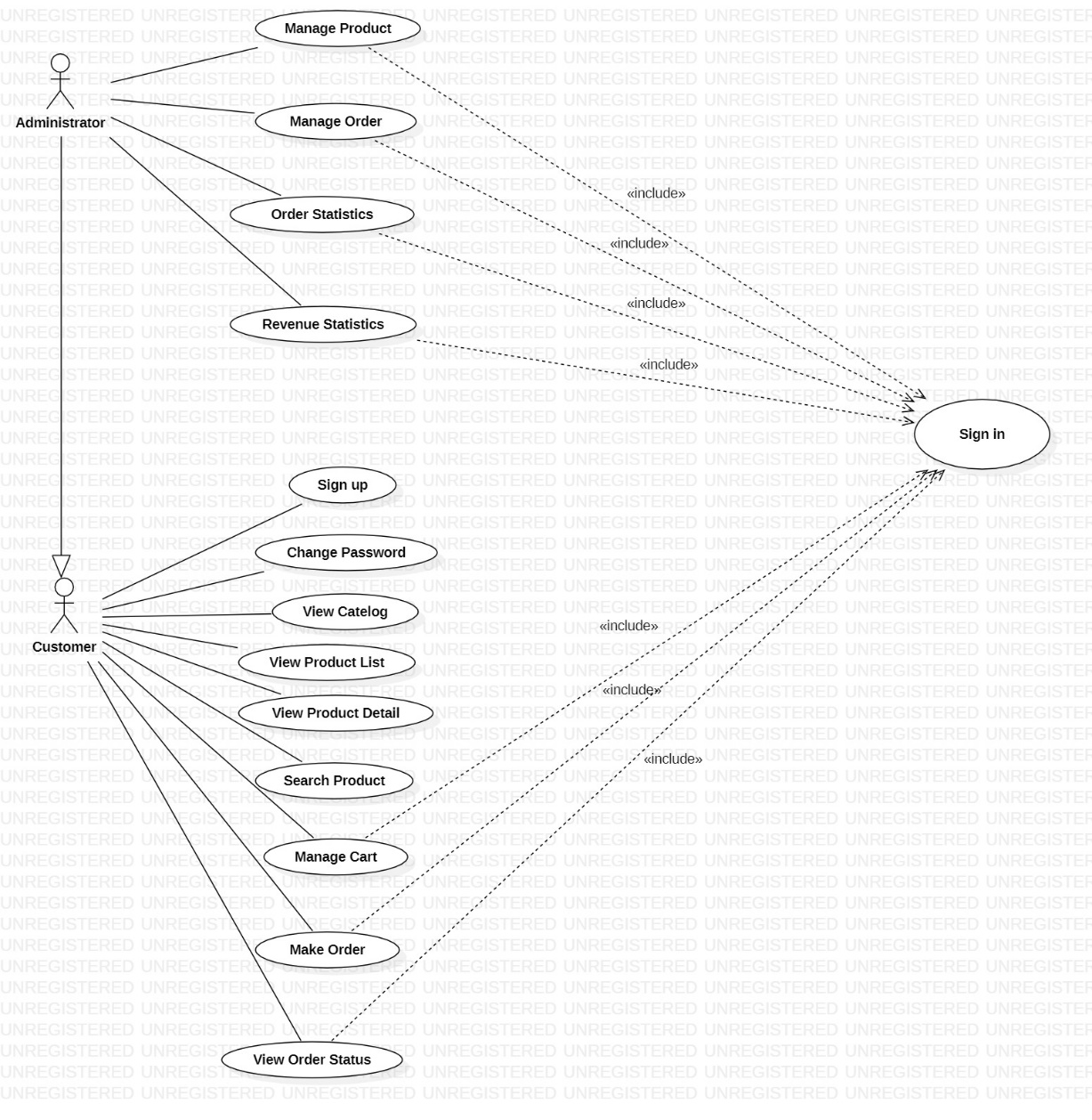

*Diagram 1: Use case diagram as a customer and an administrator*

**- Customer:**

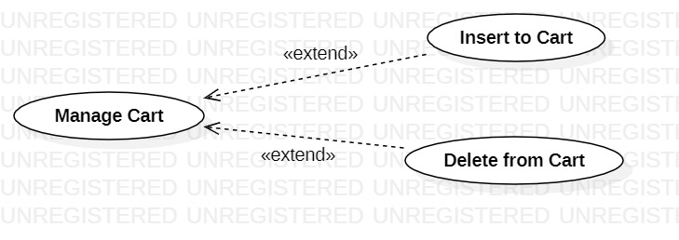

*Diagram 2: Use case diagram of Customer’s manage order*

**- Admin:**

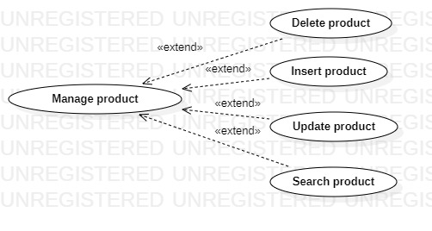

*Diagram 3: Use case diagram of Admin’s product management*

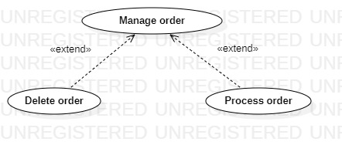

*Diagram 4: Use case diagram of Admin’s order management*

### **3.1.1. List of actors**

|  |  |  |
| --- | --- | --- |
| **Index** | **Actors** | **Meaning** |
| 1 | Administrator | People manage the system. |
| 2 | Customer | People use partial system’s services |

### **3.1.2. List of use-case**

|  |  |  |
| --- | --- | --- |
| **Role** | **Use case** | **Meaning** |
| Customer’s role | 1. Sign up | Sign up for membership |
| 2. Sign in | Sign in for using services |
| 3. Change password | Change password if customer forget it |
| 4. View catalog | Select product by catalog |
| 5. View product list | View list of existing product |
| 6. View product detail | Search information of product such as product name, branch… |
| 7. Search product | Search information of product such as product name, branch… |
| 8. Manage cart | Insert/Delete product in cart |
| 9. Make order | Purchase product order |
| 10. View order status | View status of purchased order |
| Admin’s  role | 11. Sign in | Sign in to play the role |
| 12. Manage product | Insert/Update/Delete product |
| 13. Manage order | Process/Delete order |
| 14. Order statistics | Statistics on the number of orders in progress, order delivered, order approve, order decline |
| 15. Revenue statistics | Revenue statistics by week, month, year. |

## **3.2. Use-case specification and activity diagram**

### **3.2.1. Sign up**

|  |  |
| --- | --- |
| Use-case name | Sign up |
| Description | Customers create an account for all system services. |
| Trigger | Customers click to button “Sign Up” or “Create an account”. |
| Pre-condition3 | Customer’s devices must connect to Internet. |
| Post-condition | Customer gets a notification about sign up successful.  Customer account is created and can be used to sign in for a next time. |
| Basic flow | 0. Customers clicks on sign up / create an account button  1. System display sign up page.  2. Customer enter information such as email, password, name, ... and click confirm  3. System validate customer entered information in correct format.  4. System validates customer information unique in database.  5. System store customer information in the database.  6. System notify customer that account created, customer can sign-in by using this account. |
| Alternative flow | 3a. System display invalid information due to wrong format.  Use-case continue at step 2.  4a. System display invalid information due to maybe have an existed account with customer entered information.  Use-case continue at step 2. |
| Exception flow |  |

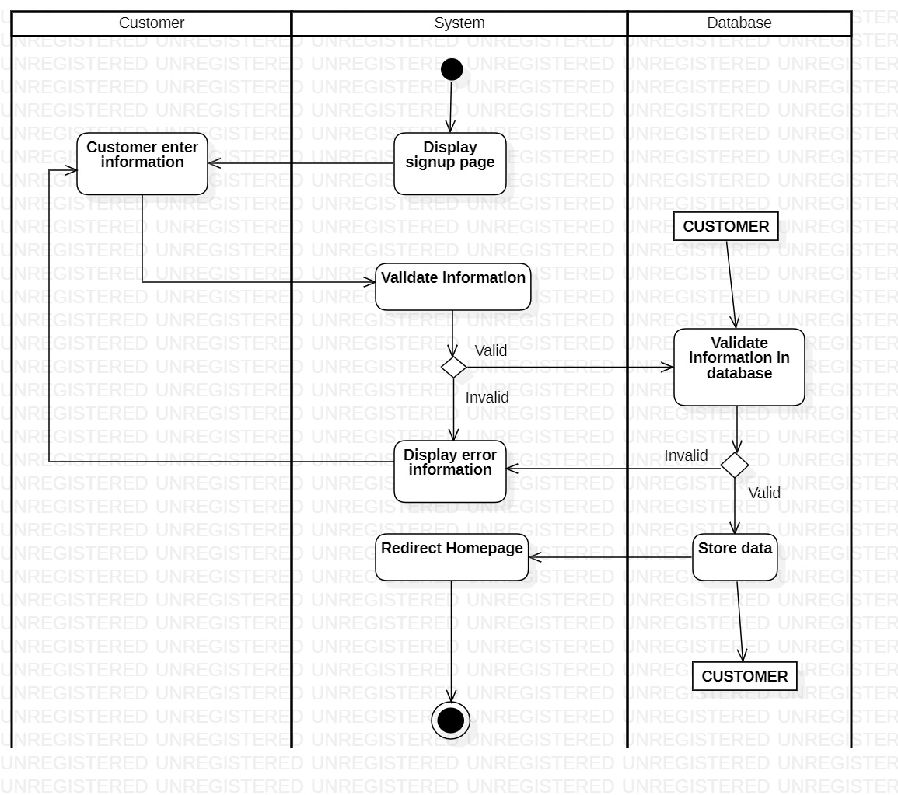

### **3.2.2. Sign in**

|  |  |
| --- | --- |
| Use-case name | Sign in |
| Description | Customers use exist account to sign-in to system for all services. |
| Trigger | Customers click to button “Sign in” |
| Pre-condition | Customer’s devices must connect to Internet.  Customer’s account must have been created. |
| Post-condition | Customer gets a notification about sign in successful.  Customers redirected to home page and customers can use services |
| Basic flow | 0. Customers clicks on sign in button on nav bar  1. System display sign in page.  2. Customers enter email & password and click confirm.  3. System validate email & password in correct format.  4. System validate customer’s input data with existed account data in database…  5. System store sign-in status using sessions.  6. System redirect to home page.  7. System save customers sign-in status. |
| Alternative flow | 3a. System display invalid information due to wrong format.  Use-case continue at step 2.  4a. System display invalid information due to customer’s account information does not match with existed account information in database.  Use-case continue at step 2. |
| Exception flow |  |

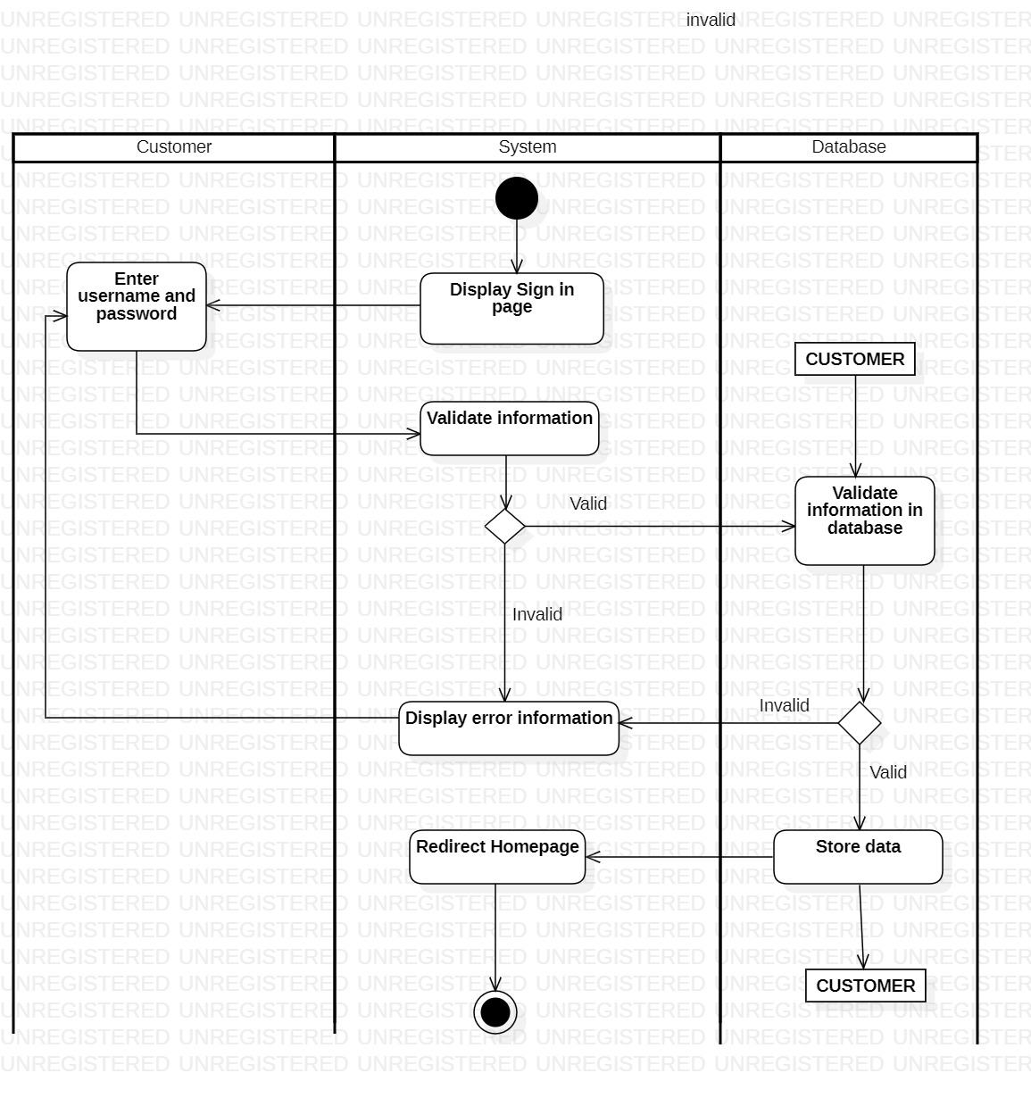

### **3.2.3. Change password**

|  |  |
| --- | --- |
| Use-case name | Change password |
| Description | Customers forgot password or want to change. |
| Trigger | Customers click “Forgot password” button in order page |
| Pre-condition | Customer’s devices must connect to Internet  Customer’s accounts existed  Customers forgot password and cannot sign-in  Customers must remember sign-up email |
| Post-condition | Customers get an email containing new password notification about sign in successful.  Customer’s password will be update in the database |
| Basic flow | 1. Customers clicks on “Forgot password” button  2. System display forgot password page  3. Customers enter signed-up email  4. System validates customers’ email in correct format  5. System validates email of customer in database.  6. System send ResetPassword email to customer’s mail  7. Customer click in the link in the ResetPassword email to enter and confirm new password.  8. System store new password in database and redirect to HomePage. |
| Alternative flow | 4a. System display invalid information due to wrong format  Use-case continue at step 3  5b. System display invalid information due to no existed account been signed with customers’ entered email  Use-case continue at step 3 |
| Exception flow |  |

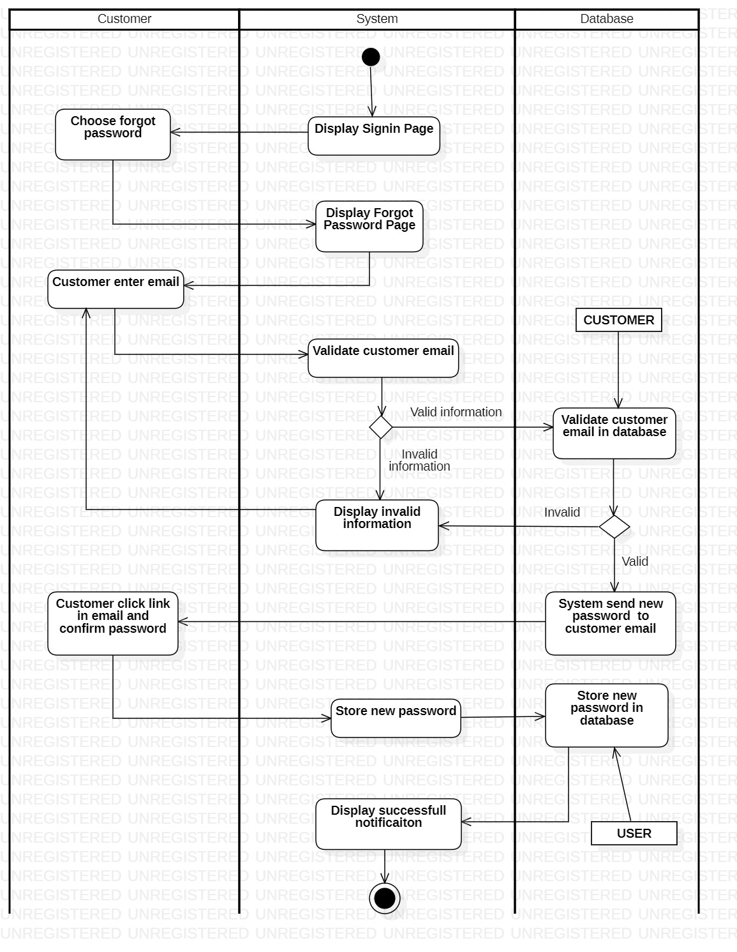

### **3.2.4. View Categories**

|  |  |
| --- | --- |
| Use-case name | View categories |
| Description | Customers choose to view existing catelog |
| Trigger | Customers click to button “Product” |
| Pre-condition | Customer’s devices must connect to Internet. |
| Post-condition | Customer gets list of products split by catelog |
| Basic flow | 1. Customers clicks on button “Product”  2. System queries list of current categories  3. System displays list of current categories |
| Alternative flow |  |
| Exception flow |  |

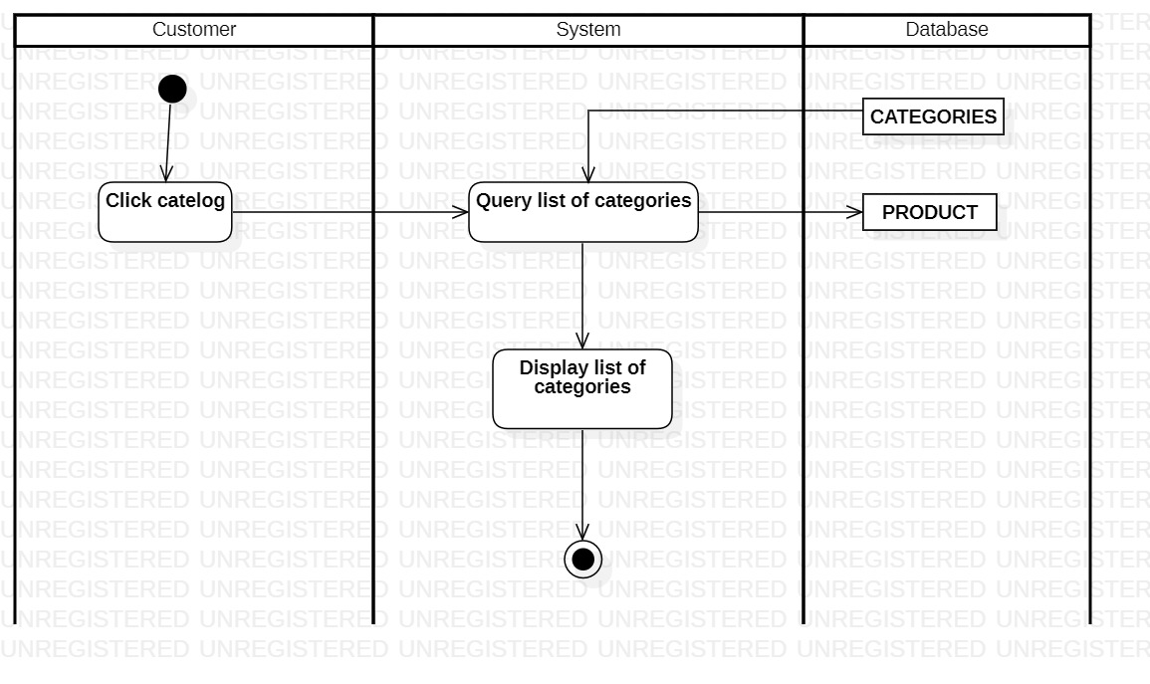

### **3.2.5. View products list**

|  |  |
| --- | --- |
| Use-case name | View products list |
| Description | Customers choose to view products list |
| Trigger | Customers click to button “Product” |
| Pre-condition | Customer’s devices must connect to Internet. |
| Post-condition | Customer gets list of existing products |
| Basic flow | 1. Customers click on button “Product” and choose one catalog that they prefer  2. System queries list of current selling products from the catalog they have chosen  3. System displays list of current selling products from the catalog they have chosen. |
| Alternative flow |  |
| Exception flow |  |

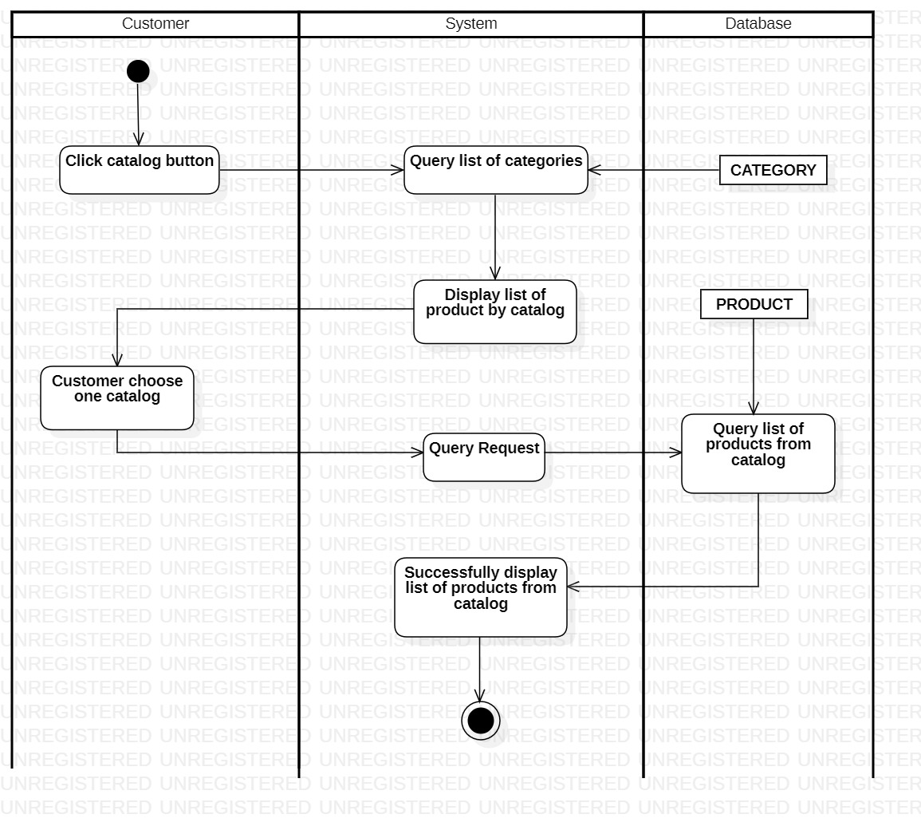

### **3.2.6. View product detail**

|  |  |
| --- | --- |
| Use-case name | View products detail |
| Description | Customers choose to view detail of a product |
| Trigger | Customers click to button “Product” or “Catalog” |
| Pre-condition | Customer’s devices must connect to Internet. |
| Post-condition | Customer gets detail of product information |
| Basic flow | 1. Customers clicks on button “Products”  2. System queries list of current selling products  3. System displays list current selling products.  4. Customers select a product  5. System redirect customers to detailed product page  6. System display detailed information to customers |
| Alternative flow |  |
| Exception flow |  |

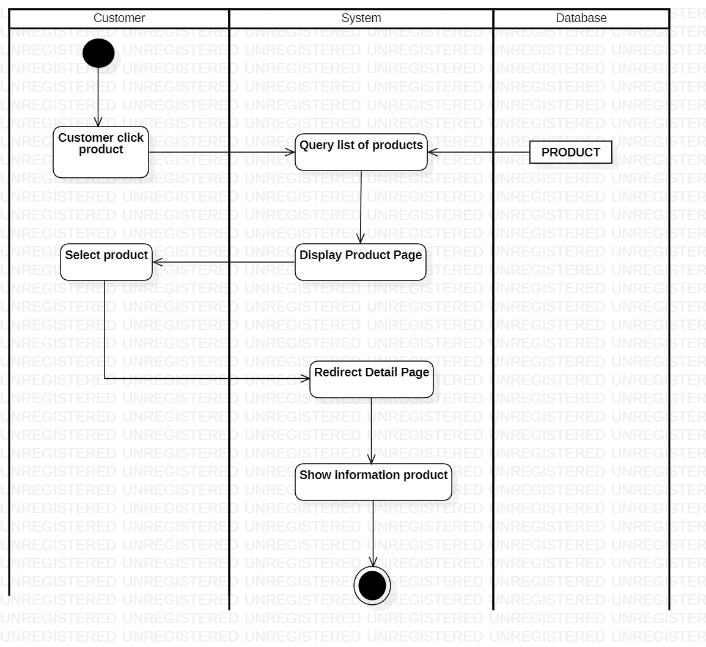

### **3.2.7. Search product**

|  |  |
| --- | --- |
| Use-case name | Search product |
| Description | Customers search a product including some words |
| Trigger | Customers click to button “Search” |
| Pre-condition | Customer’s devices must connect to Internet. |
| Post-condition | Customer gets a list of products with detail information |
| Basic flow | 1. Customers enter keywords on text field at nav bar then click “Search” button (with magnifying glass icon)  2. System processing request  3. System queries list of products related to keywords  4. System display result with detailed products. |
| Alternative flow | 3a. System shows empty information  Use-case continue at step 1 |
| Exception flow |  |

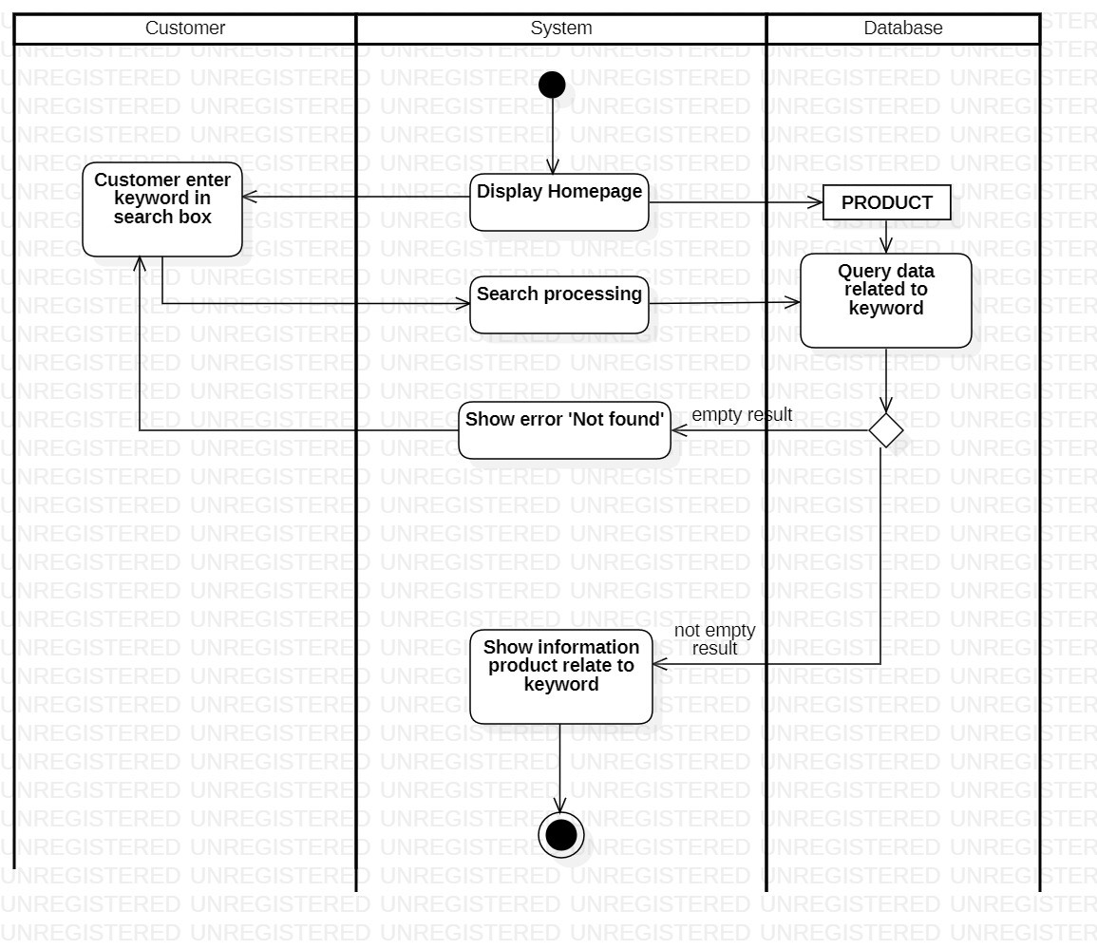

### **3.2.8. Manage cart**

***3.2.8.1. Insert to cart***

|  |  |
| --- | --- |
| Use-case name | Insert to cart |
| Description | Customers add product want to buy to cart |
| Trigger | Customers click to button “Add to cart” |
| Pre-condition | Customer’s devices must connect to Internet. |
| Post-condition | Customer add product to cart successfully |
| Basic flow | 1. Customers clicks on button “Add to cart”  2. System processing request  3. System update data in cart  4. System display OrderPage with update product |
| Alternative flow |  |
| Exception flow |  |

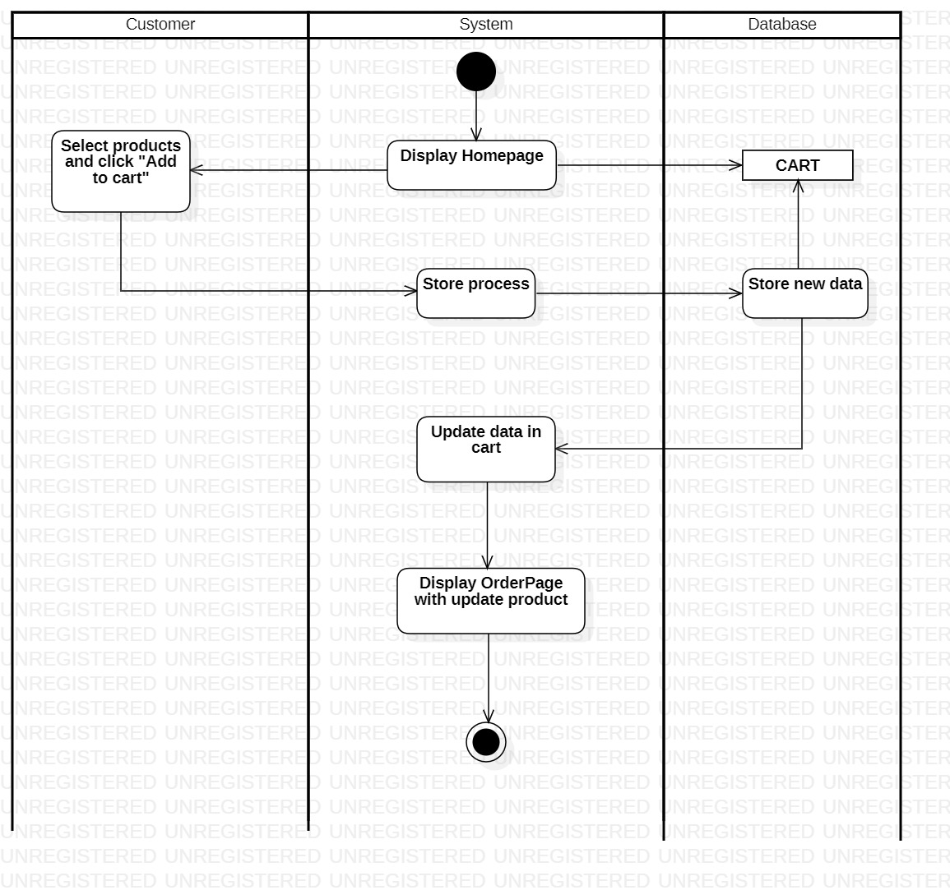

#### **3.2.8.2. Delete from cart**

|  |  |
| --- | --- |
| Use-case name | Delete from cart |
| Description | Customers delete product do not want to buy from cart |
| Trigger | Customers click to button “Delete” |
| Pre-condition | Customer’s devices must connect to Internet. |
| Post-condition | Customer delete product from cart successfully |
| Basic flow | 1. Customers clicks on button “Delete”  2. System processing request  3. System display successfully message  4. System display OrderPage with update product |
| Alternative flow |  |
| Exception flow |  |

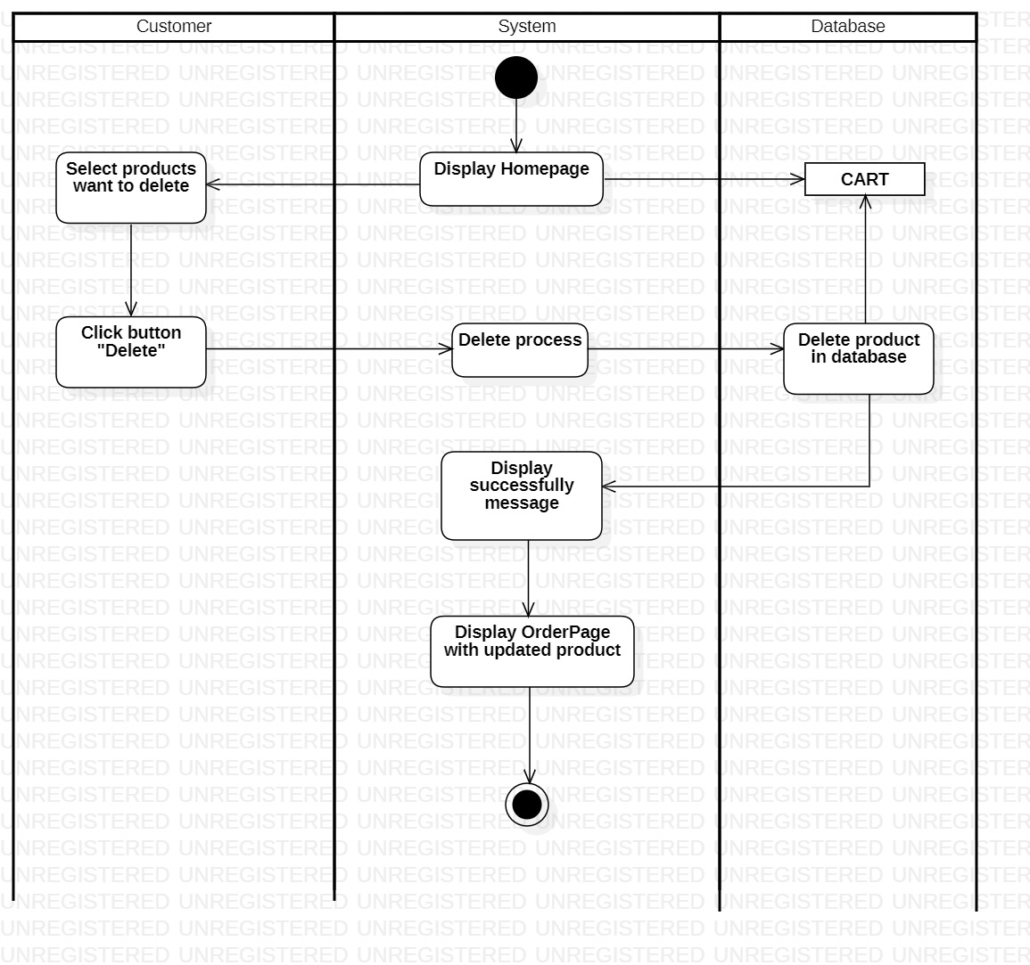

### **3.2.9. Make order**

|  |  |
| --- | --- |
| Use-case name | Make order |
| Description | Customers place existing order |
| Trigger | Customers click “Place order” button in order page |
| Pre-condition | Customer have added product to cart  Customer’s status is signed-in. |
| Post-condition | Customers place order successfully.  Customer’s payment information is stored into the database. |
| Basic flow | 1. System display customer order page.  2. Customer select button ”Place order”  3. System processes order request  4. System redirect customer to pay page to input customer information.  5. Customers select appropriate payment method.  6. Customers confirm to pay (by clicking “Send order” button).  7. System process payment.  8. System waits for payment from customers  9. System store payment information in database.  10. System displays successful message to customers and redirect to homepage. |
| Alternative flow | 10a. System display payment failure reason from payment provider if payment information failure.  Use-case continue at step 5. |
| Exception flow |  |

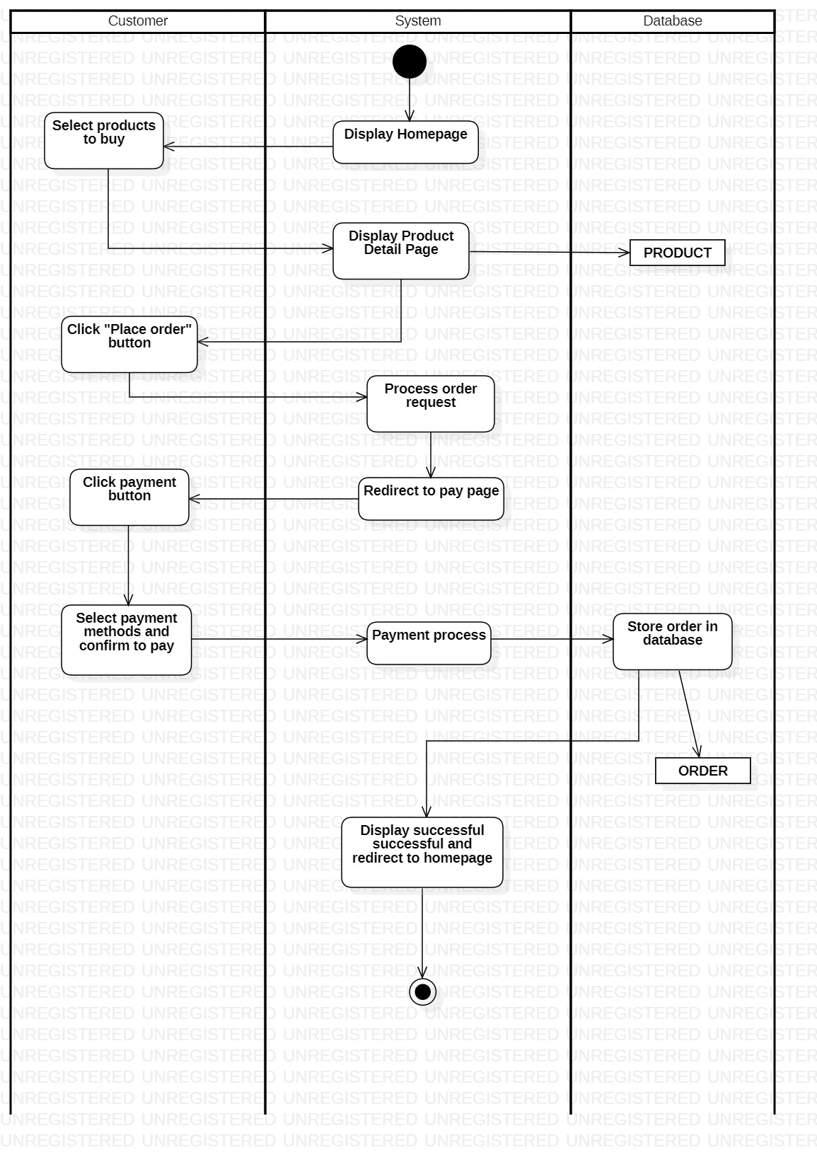

### **3.2.10. View order status**

|  |  |
| --- | --- |
| Use-case name | View order status |
| Description | Customers can see purchased products or paid transaction. |
| Trigger | Customers click “Order status” button on nav bar |
| Pre-condition | Customer’s devices must connect to Internet  Customer’s accounts existed  Customer’s status is signed-in |
| Post-condition | Customers get order status with detailed information. |
| Basic flow | 1. Customers clicks on button “Order status”  2. System queries customers information and customers order status based on signed-in status  3. System display order status on the page with detailed information |
| Alternative flow |  |
| Exception flow |  |

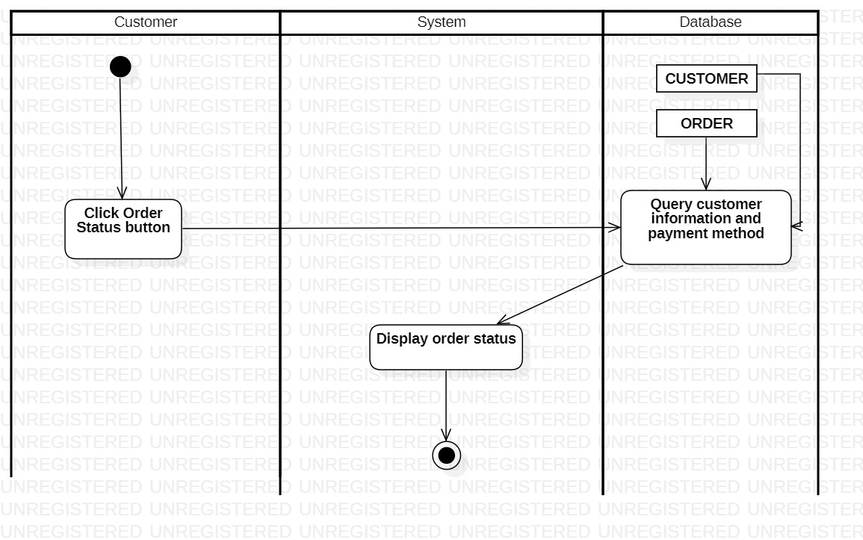

### **3.2.11. Sign in (for Administrator)**

|  |  |
| --- | --- |
| Use-case name | Sign in |
| Description | Administrator use granted account to sign-in to system for all monitoring. |
| Trigger | Administrators clicks to button “Sign in” at nav bar |
| Pre-condition | Administrators’ device must connect to Internet  Administrators’ account existed |
| Post-condition | Administrators is redirected to management page |
| Basic flow | 1. Administrators clicks “Sign in” button at management page  2. System display management sign-in page  3. Administrators enter email & password  4. System validate administrators entered email & password in correct format  5. System compares the information provided by administrators to the information stored in the database.  6. Using sessions, the system keeps track of whether administrators are signed in.  7. System redirect to management page. |
| Alternative flow | 3a. System display invalid information due to wrong format.  Use-case continue at step 2.  4a. System display invalid information due to administrators’ account information does not match with existed account information in database.  Use-case continue at step 2. |
| Exception flow |  |

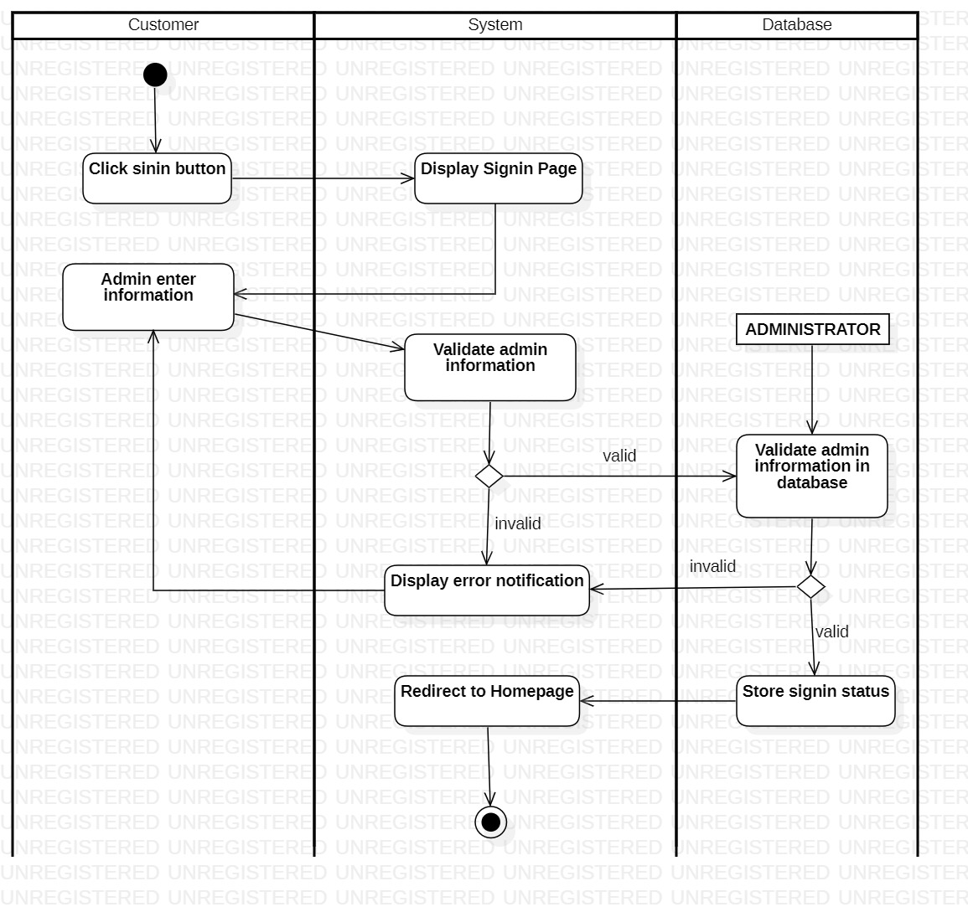

### **3.2.12. Manage product**

#### **3.2.12.1. Insert product**

|  |  |
| --- | --- |
| Use-case name | Insert product |
| Description | Administrator can insert a product to database |
| Trigger | Administrators clicks to button “Insert product” at product management page |
| Pre-condition | Administrators’ device must connect to Internet  Administrators’ account existed  Administrator’s status is signed-in. |
| Post-condition | New product information successful insert to database  Data at management page is updated (with new product) |
| Basic flow | 1. System display store management page with data loaded from database (existed products)  2. Administrators select products management.  3. System display product management page.  4. Administrators select insert function  5. System display product information form  6. Administrators enter product information  7. System validate product information in correct format  8. System validates product information with existed data in database.  9. System stores product information in database  10. System updates data at product management page with inserted data (new data).. |
| Alternative flow | 7a. System display invalid information due to wrong format.  Use-case continue at step 6.  8b. System display invalid information because data had been existed in the database.  Use-case continue at step 6. |
| Exception flow |  |

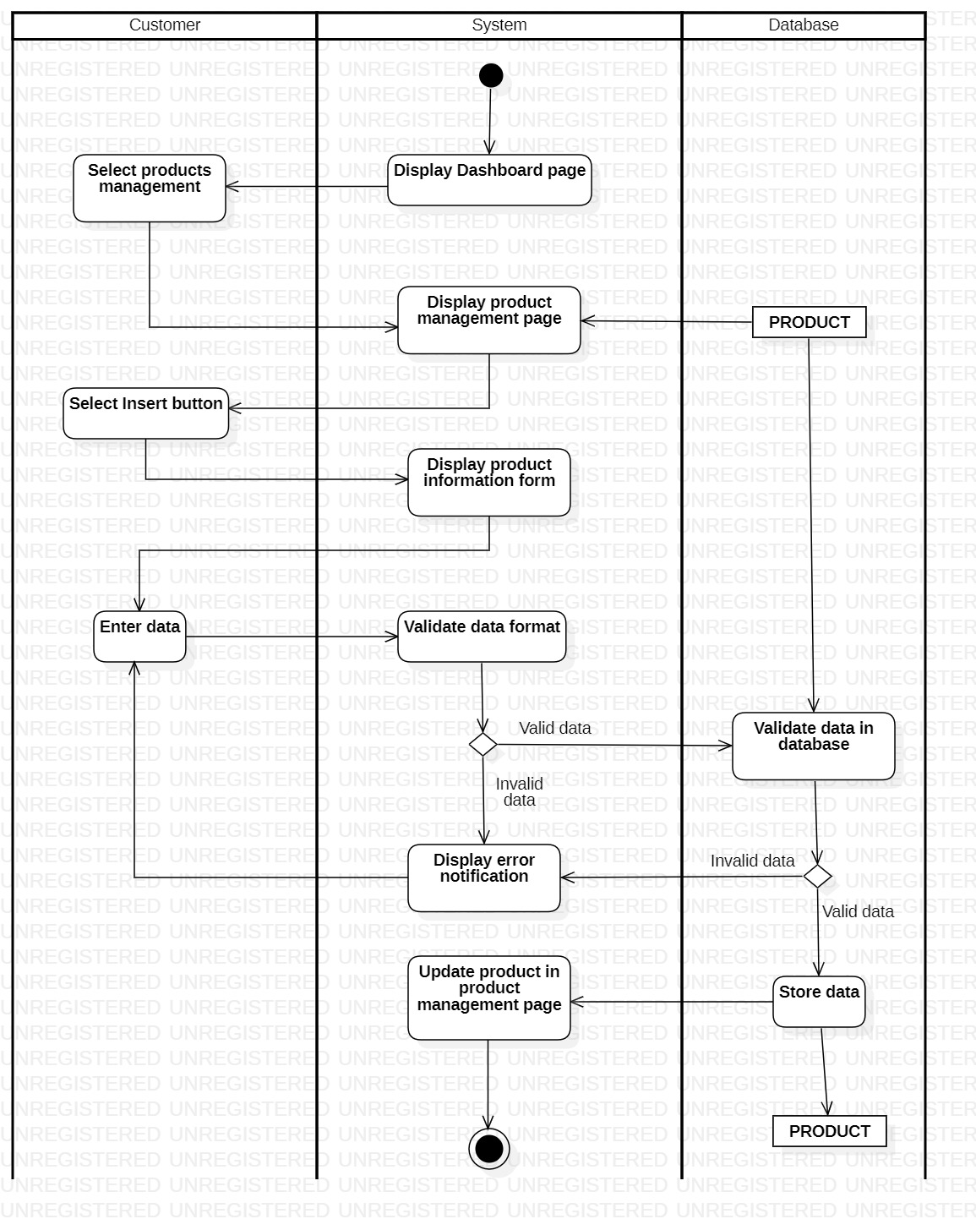

***3.2.12.2. Update product***

|  |  |
| --- | --- |
| Use-case name | Update product |
| Description | Administrator can update a existing product to database |
| Trigger | Administrators clicks to button “Update product” at product management page |
| Pre-condition | Administrators’ device must connect to Internet  Administrators’ account existed  Administrator’s status is signed-in.  Product information must be existed in database before updating |
| Post-condition | New product information successful updated to database data at management page is updated (with new information product) |
| Basic flow | 1. System display store management page with data loaded from database (existed products)  2. Administrator select products management.  3. System display product management page.  4. Administrators select update function and product to be updated.  5. System display product information form with existing data  6. Administrators modify product data  7. System validate product information in correct format  8. System validates product information with existed data in database.  9. System updates product information in database  10. System updates data at product management page with updated data (new data)… |
| Alternative flow | 7a. System display invalid information due to wrong format.  Use-case continue at step 6.  8b. System display invalid information because data had been existed in the database.  Use-case continue at step 6. |

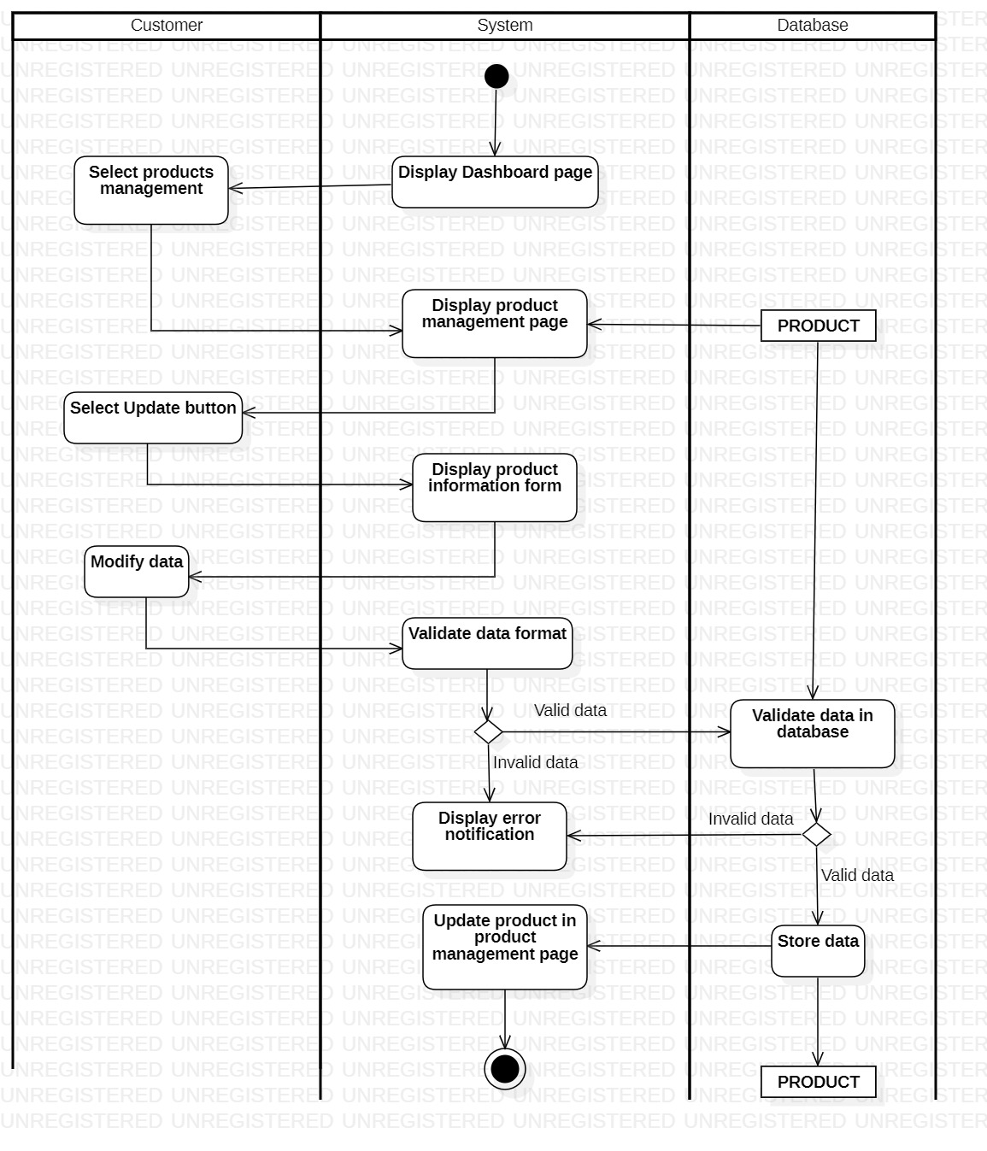

#### **3.2.13.3 Delete product**

|  |  |
| --- | --- |
| Use-case name | Delete product |
| Description | Administrator can delete a existing product to database |
| Trigger | Administrators clicks to button “Delete product” at product management page |
| Pre-condition | Administrators’ device must connect to Internet  Administrators’ account existed  Administrator’s status is signed-in.  Product information must be existed in database before deleting |
| Post-condition | Data at management page is updated (selected product should been removed) |
| Basic flow | 1. System display store management page with data loaded from database (existed products)  2. Administrator select products management.  3. System display product management page.  4. Administrators select delete function and product to be deleted.  5. System process delete request  6. System validate product information  7. System delete product information in database  8. System updates data at product management page with updated data (new data).. |
| Alternative flow | 5a. System display error notification because external data had required that product information or no data existed  Use-case stop. |

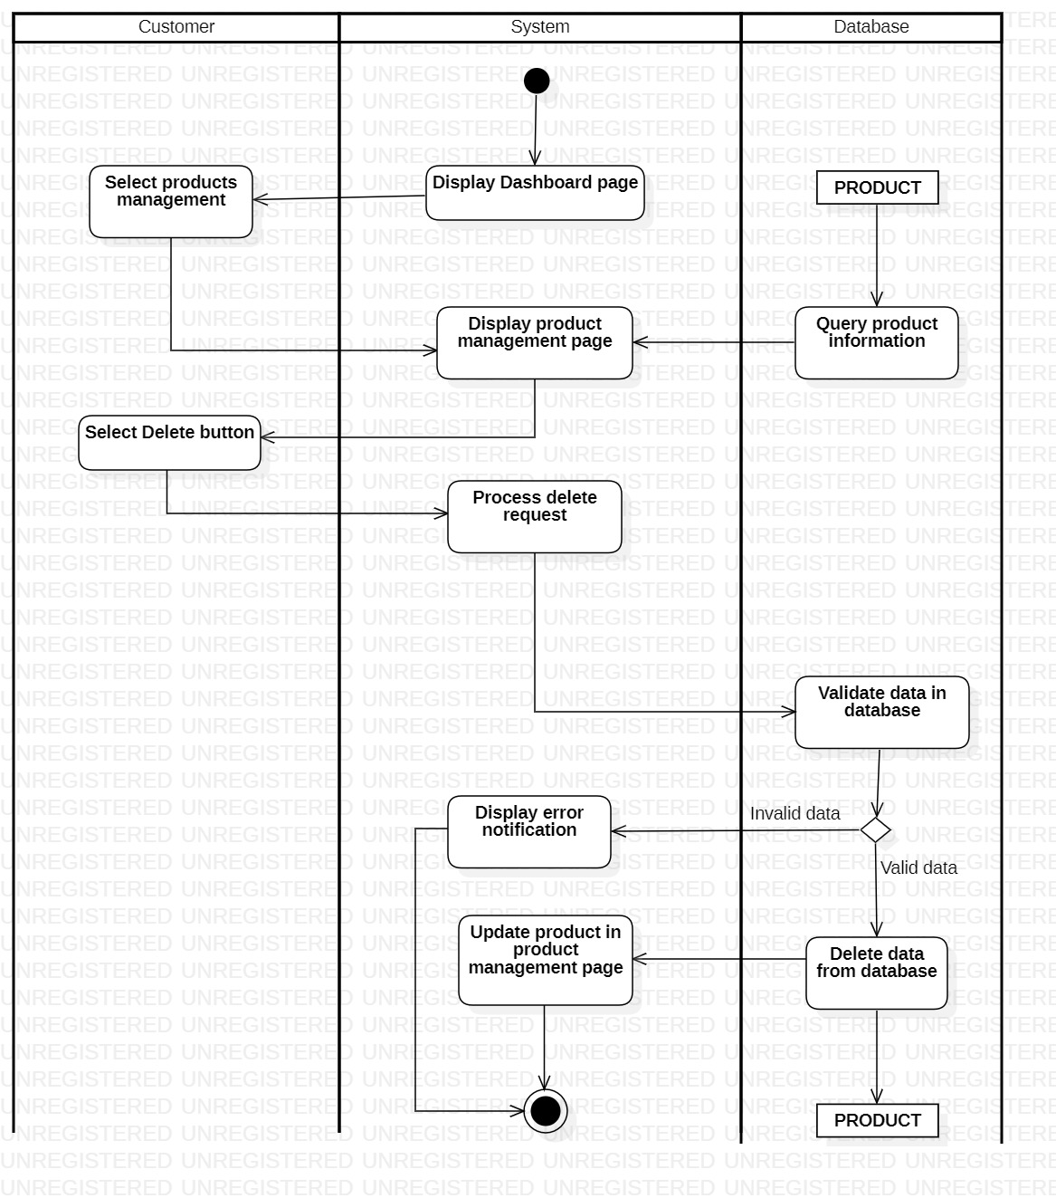

#### **3.2.13.4 Search product**

|  |  |
| --- | --- |
| Use-case name | Search product |
| Description | Administrator can search a existing product to database |
| Trigger | Administrators clicks to button “Search product” at product management page |
| Pre-condition | Administrators’ device must connect to Internet  Administrators’ account existed  Administrator’s status is signed-in.  Product information must be existed in database before deleting |
| Post-condition | Data at management page is filtered by keywords |
| Basic flow | 1. System display store management page with data loaded from database (existed products)  2. Administrator select products management.  3. System display product management page.  4. Administrators select search function enter keywords.  5. System process search request  6. System queries data based on keywords  7. System updates data at product management page (data related to keyword  is retained) |
| Alternative flow | 6a. System displays empty result notification  Use-case continue at step 4 (no data is retained) |

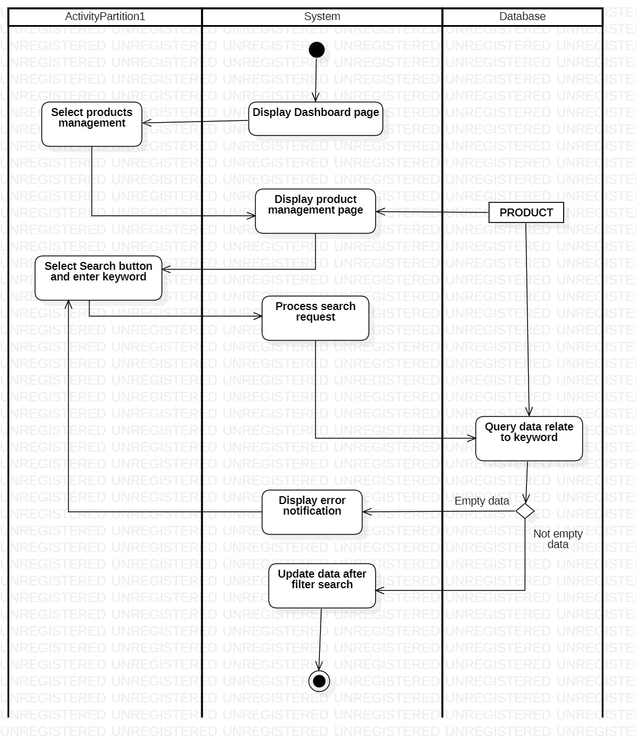

### **3.2.13. Manage order**

#### **3.2.13.1. Process order**

|  |  |
| --- | --- |
| Use-case name | Process order |
| Description | Administrator can decide to confirm an order |
| Trigger | Administrators clicks to button “Confirm” at order management page |
| Pre-condition | Administrators’ device must connect to Internet  Administrators’ account existed  Administrator’s status is signed-in.  Order information must be existed in database before modifying |
| Post-condition | New order status successful updated to database  Data at order management page is updated (with new data) |
| Basic flow | 1. System display store management page with data loaded from database (existed products)  2. Administrator select order management.  3. System display order management page.  4. Administrators select detail function  5. System query customer information and order information from database.  5. System display order information form with existing data  6. Administrators choose order status types.  7. System updates order status information in database  8. System updates data at order management page with updated data (new data).. |
| Alternative flow |  |

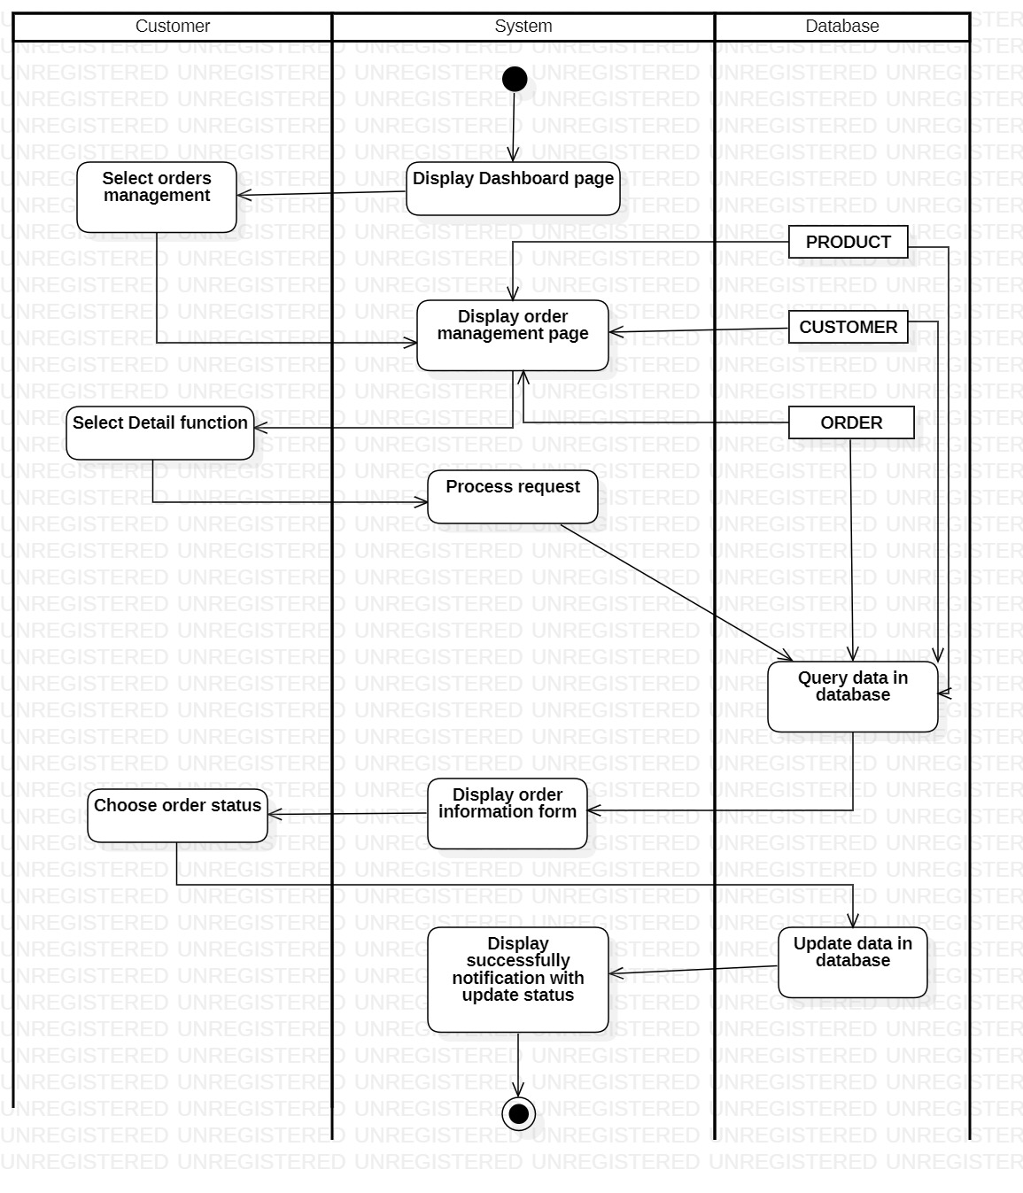

#### **3.2.13.2. Delete order**

|  |  |
| --- | --- |
| Use-case name | Delete order |
| Description | Administrator can delete an existing order |
| Trigger | Administrators clicks to button “Delete” at order management page |
| Pre-condition | Administrators’ device must connect to Internet  Administrators’ account existed  Administrator’s status is signed-in.  Order information must be existed in database before modifying |
| Post-condition | Data at order management page is updated after removing an selected order |
| Basic flow | 1. System display store management page with data loaded from database (existed products)  2. Administrator select order management.  3. System display order management page.  4. Administrators select delete function  5. System process delete request.  6. System delete order in database  7. System display successful notification |
| Alternative flow |  |

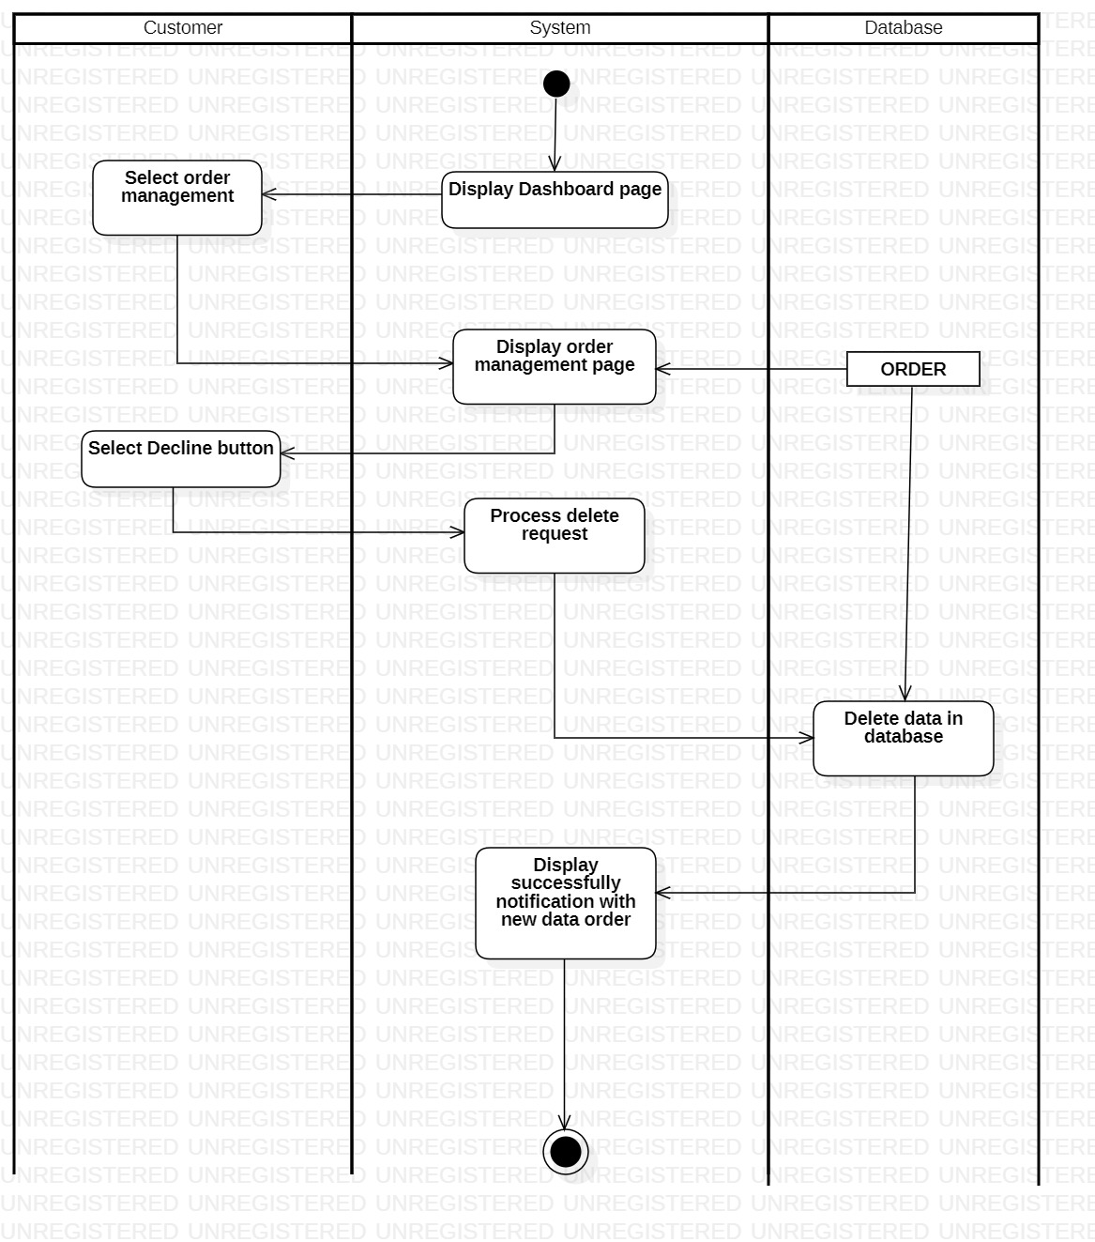

### **3.2.14. Order statistic**

|  |  |
| --- | --- |
| Use-case name | Order Statistic |
| Description | Administrator can statistics orders |
| Trigger | Administrators choose Overview Page |
| Pre-condition | Administrators’ device must connect to Internet  Administrators’ account existed  Administrator wants to display order information by status |
| Post-condition | Display order information |
| Basic flow | 1. Admin clicks Overview Page  2. System display Overview Page  3. Order information will be displayed on the page |
| Alternative flow |  |

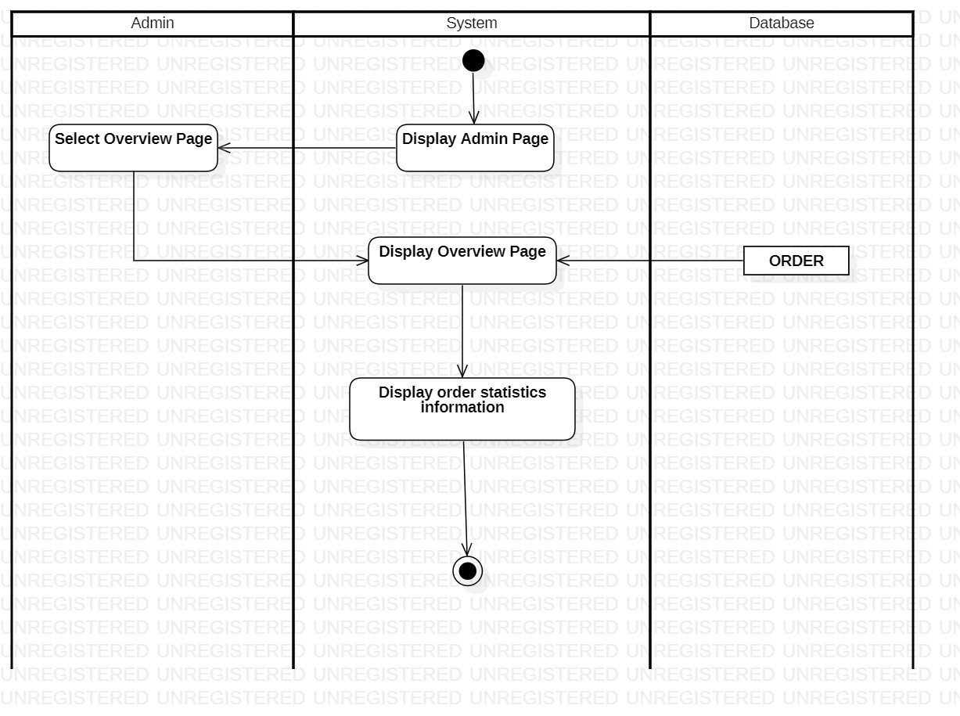

### **3.2.15. Revenue statistic**

|  |  |
| --- | --- |
| Use-case name | Revenue Statistic |
| Description | Administrator can statistics revenue |
| Trigger | Administrators choose Overview Page |
| Pre-condition | Administrators’ device must connect to Internet  Administrators’ account existed  Administrator wants to display revenue statistic. |
| Post-condition | Display revenue information |
| Basic flow | 1. Admin clicks Overview Page  2. System display Overview Page  3. Order information will be displayed on the page |
| Alternative flow |  |

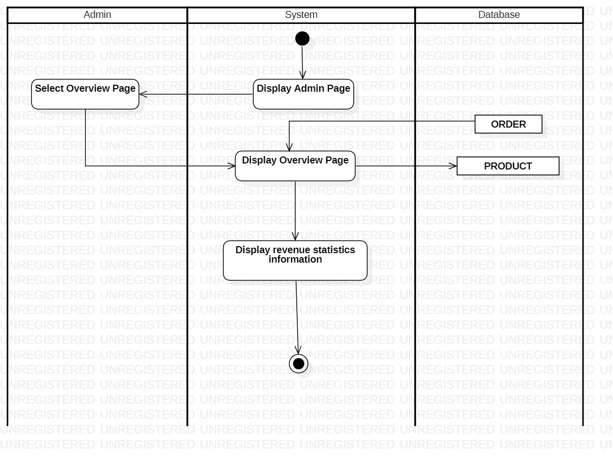

## **3.3. Sequence diagram and class diagram**

### **3.3.1. Sign up**

#### **3.3.1.1 Sequence diagram**

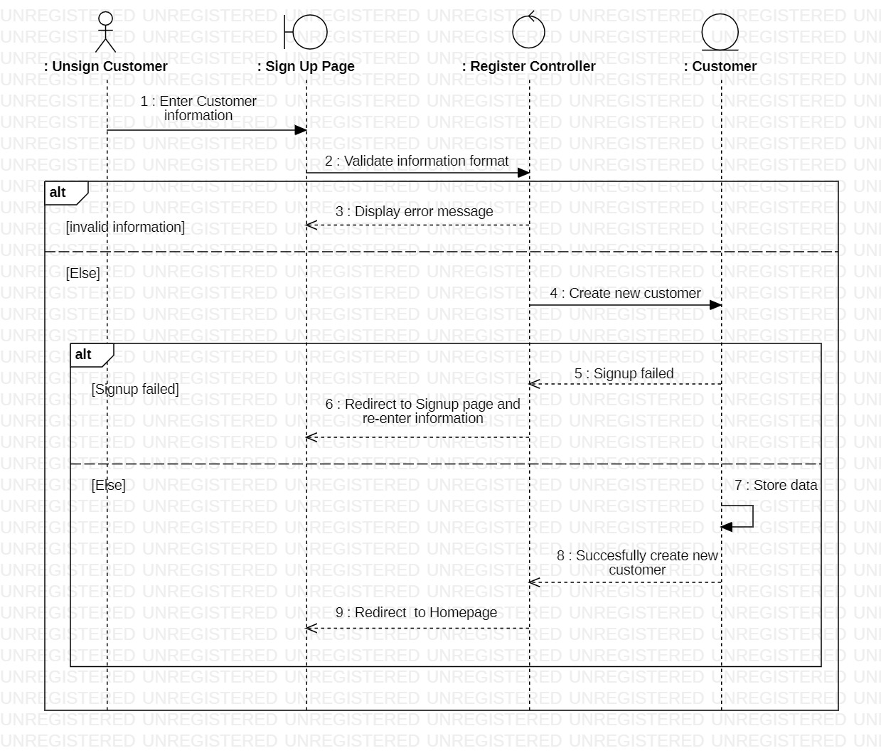

#### **3.3.1.2 Class diagram**

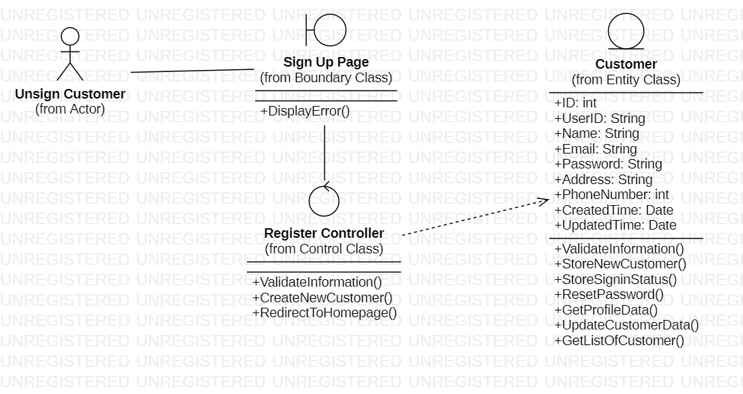

### **3.3.2. Sign in (for Customer)**

***3.3.2.1. Sequence diagram***

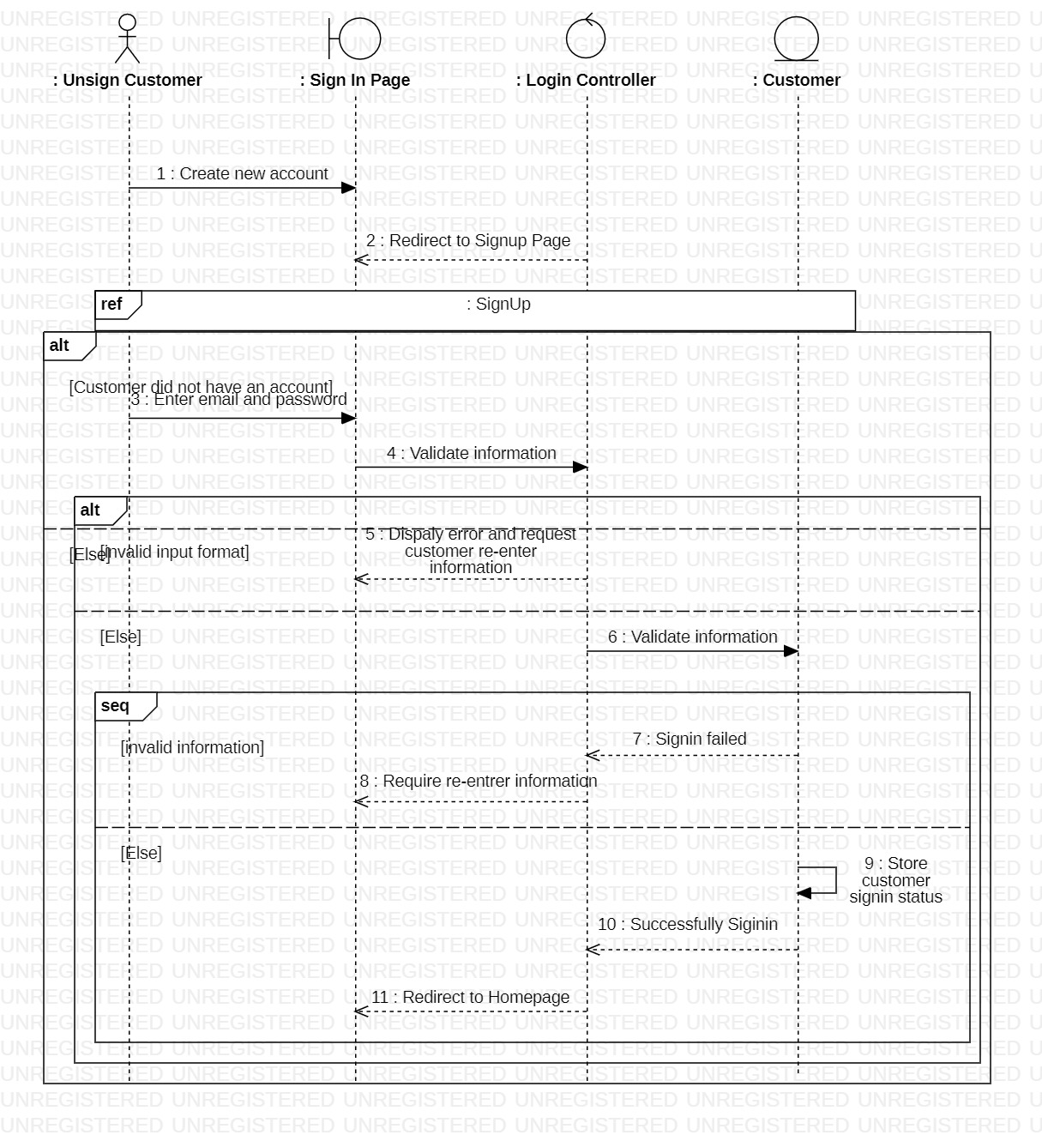

#### **3.3.2.2. Class diagram**

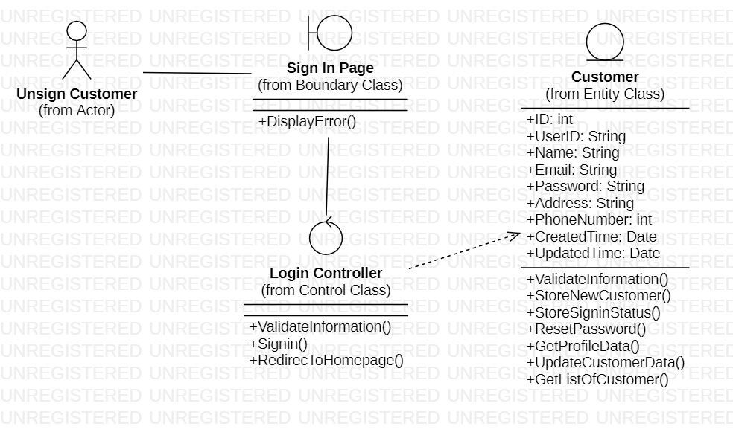

### **3.3.3. Change password**

#### **3.3.3.1 Sequence diagram**

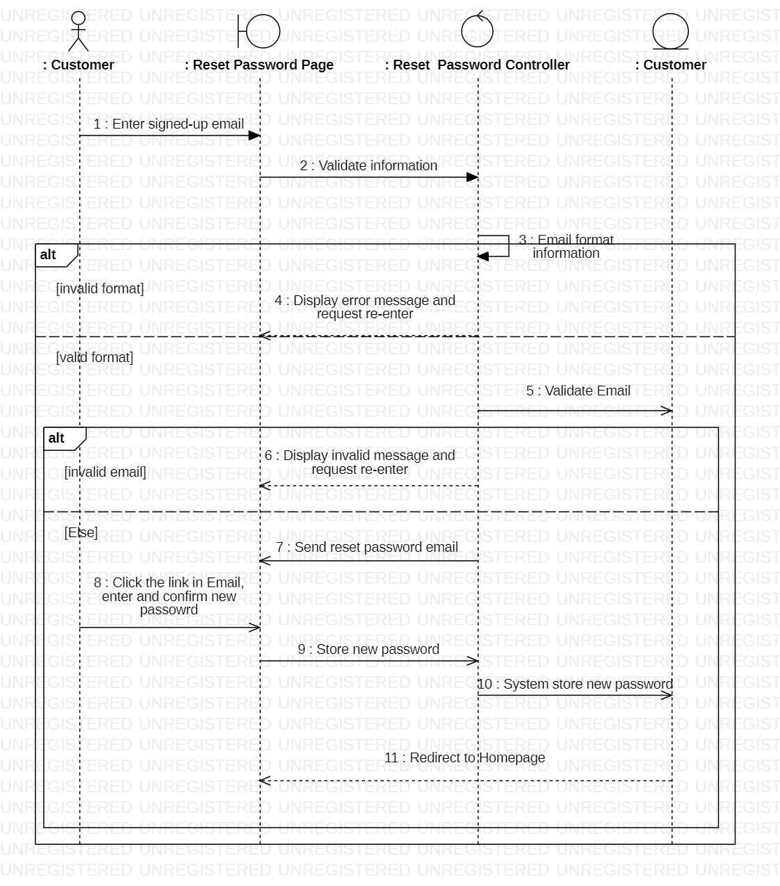

#### **3.3.3.2. Class diagram**

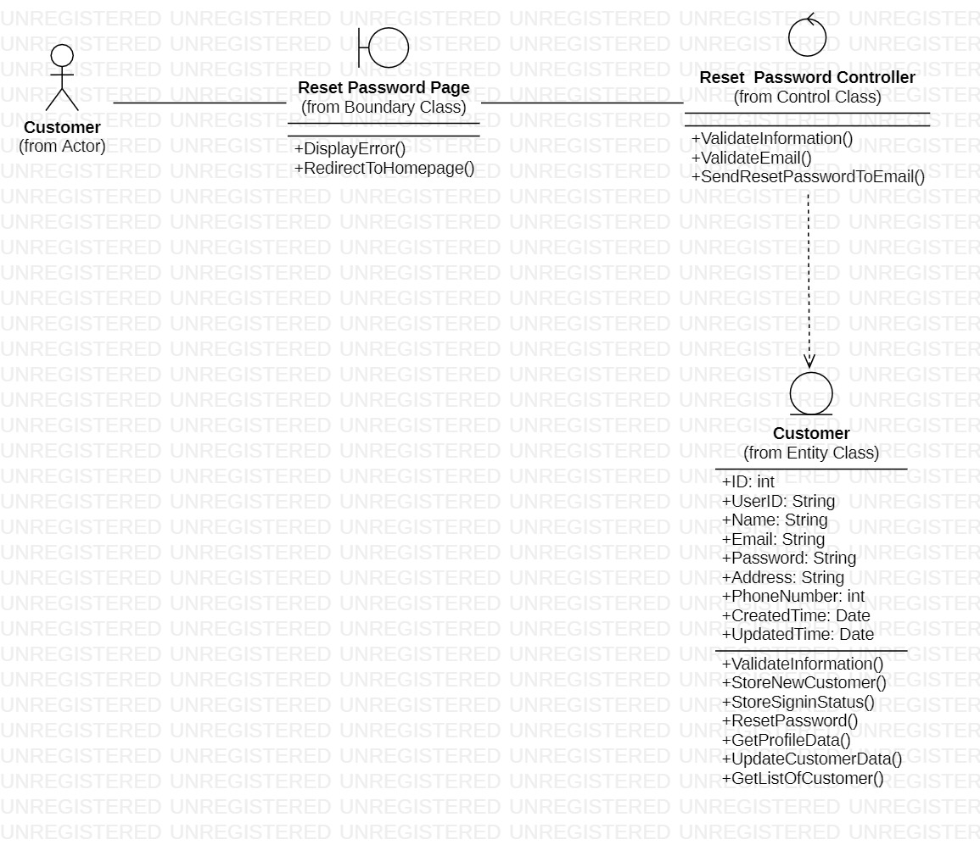

### **3.3.4. View categories**

#### **3.3.4.1. Sequence diagram**

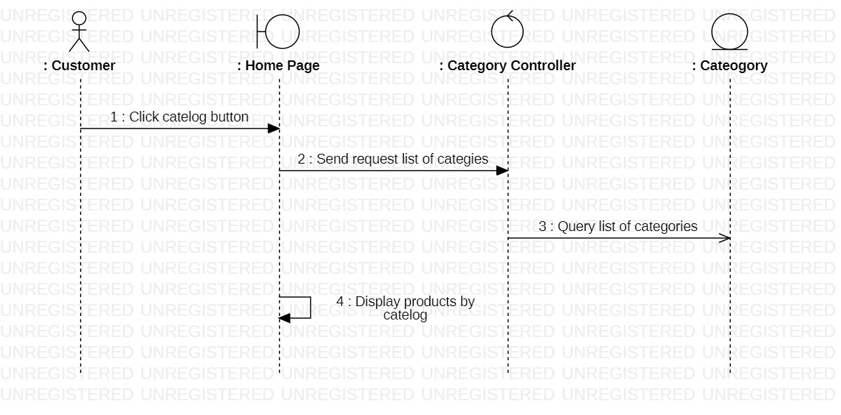

#### **3.3.4.2. Class diagram**

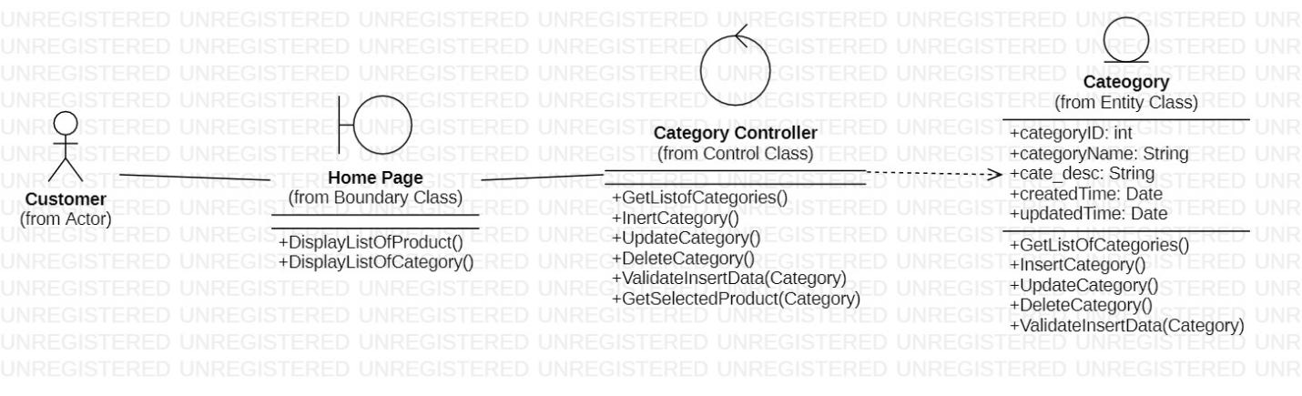

### **3.3.5. View product list**

#### **3.3.5.1. Sequence diagram**

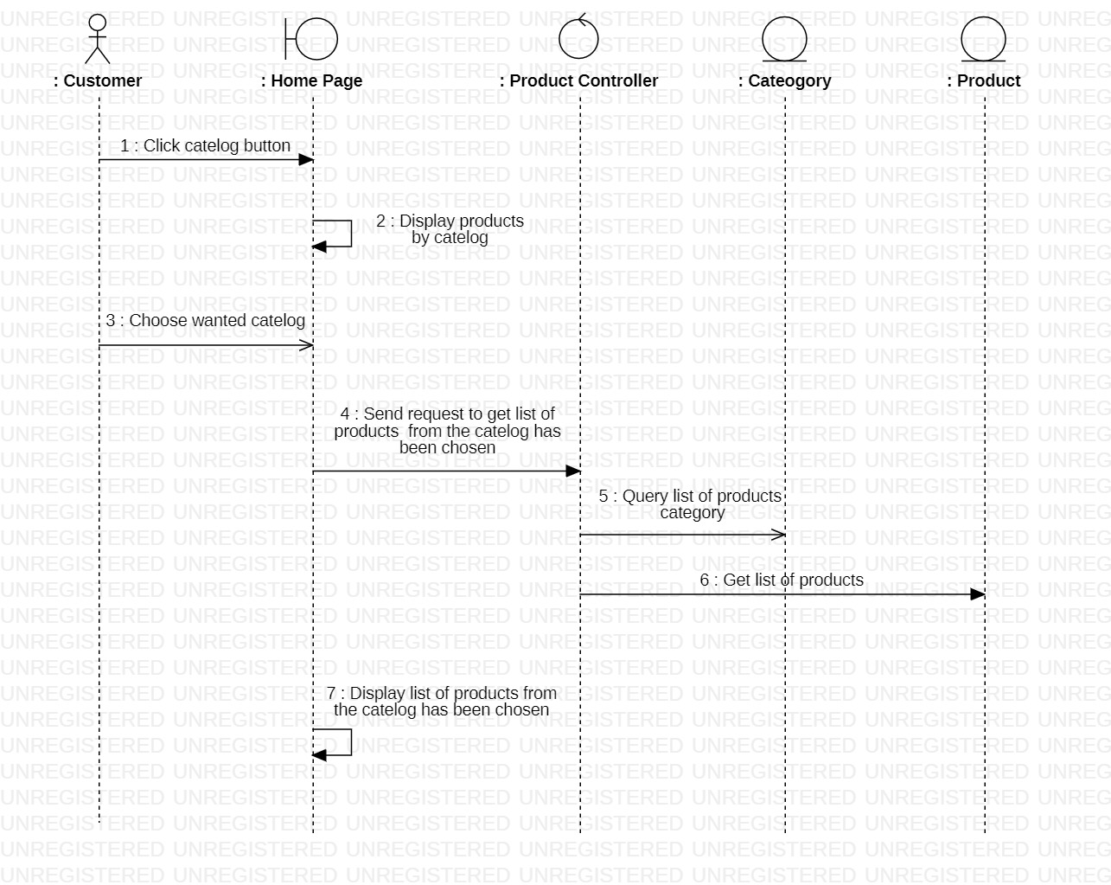

#### **3.3.5.2. Class diagram**

### **3.3.6. View product detail**

#### **3.3.6.1. Sequence diagram**

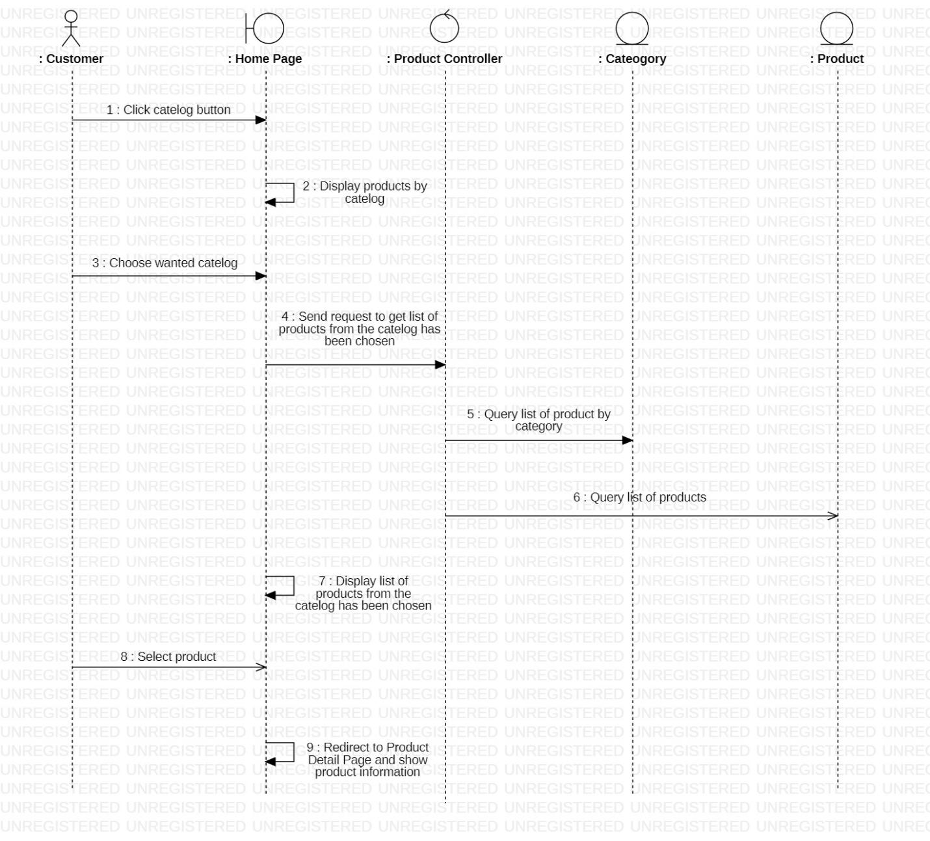

#### **3.3.6.2 Class diagram**

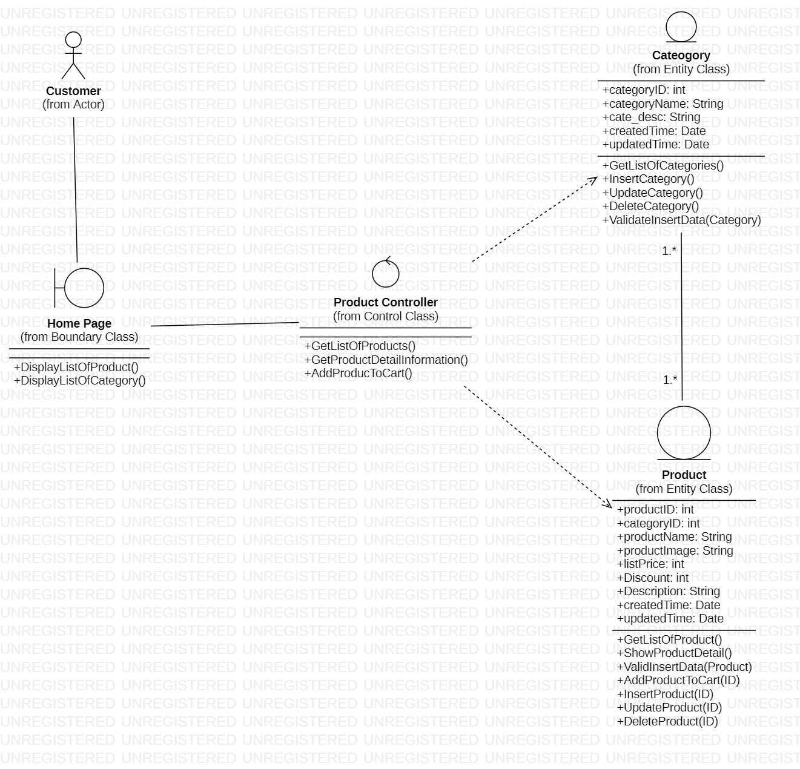

### **3.3.7. Search product**

#### **3.3.7.1 Sequence diagram**

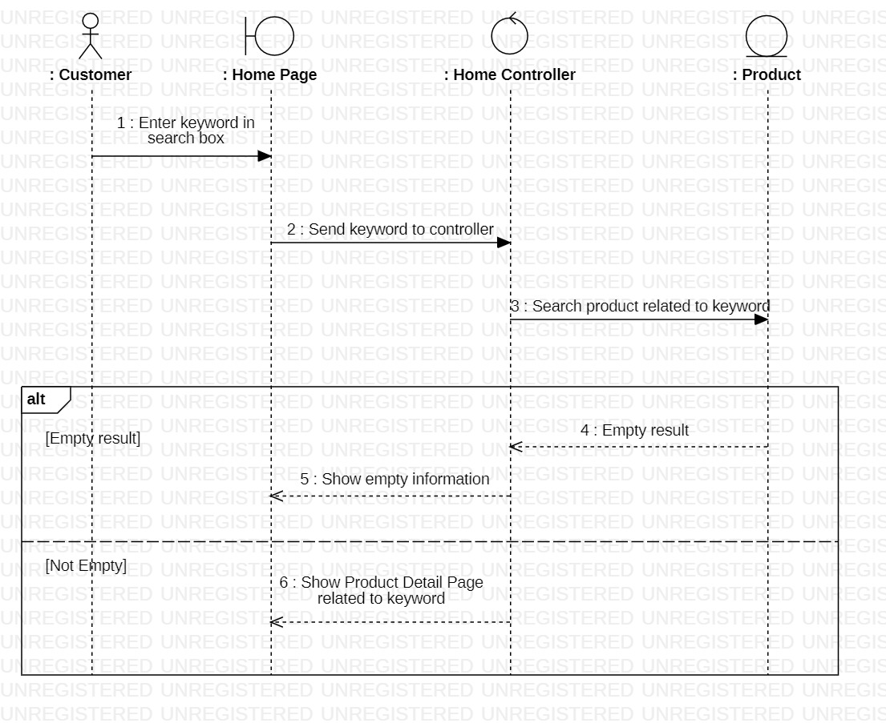

#### **3.3.7.2. Class diagram**

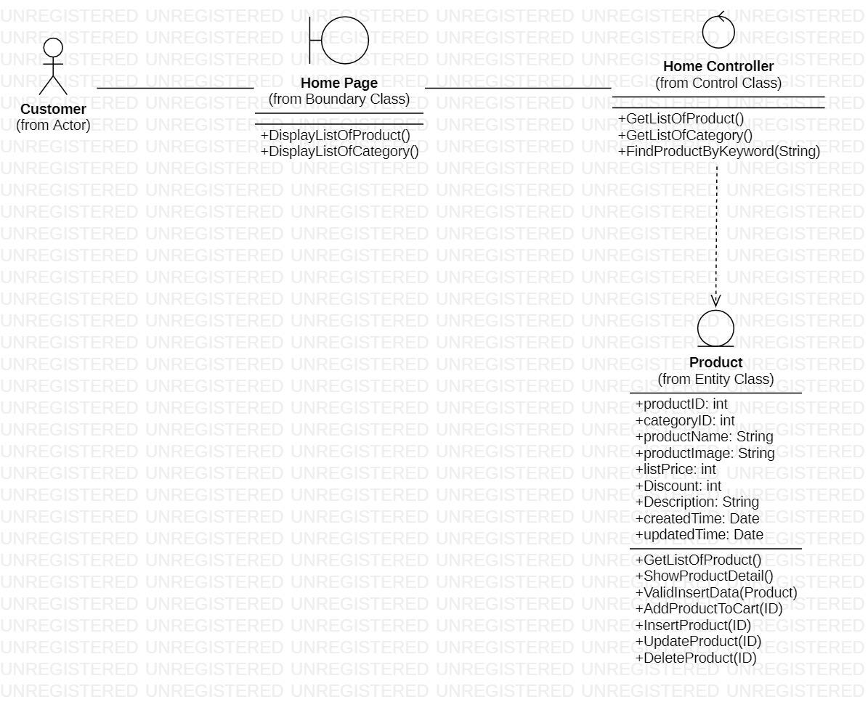

### **3.3.8. Manage cart (for customer)**

#### **3.3.8.1. Sequence diagram**

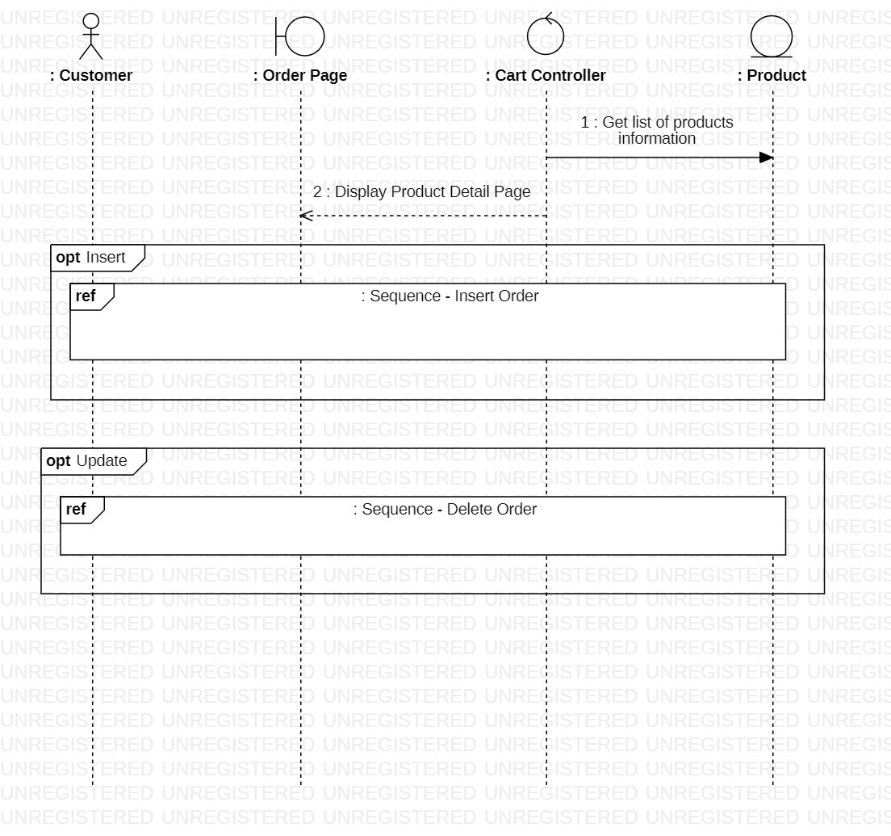

***3.3.8.1.1. Insert to cart***

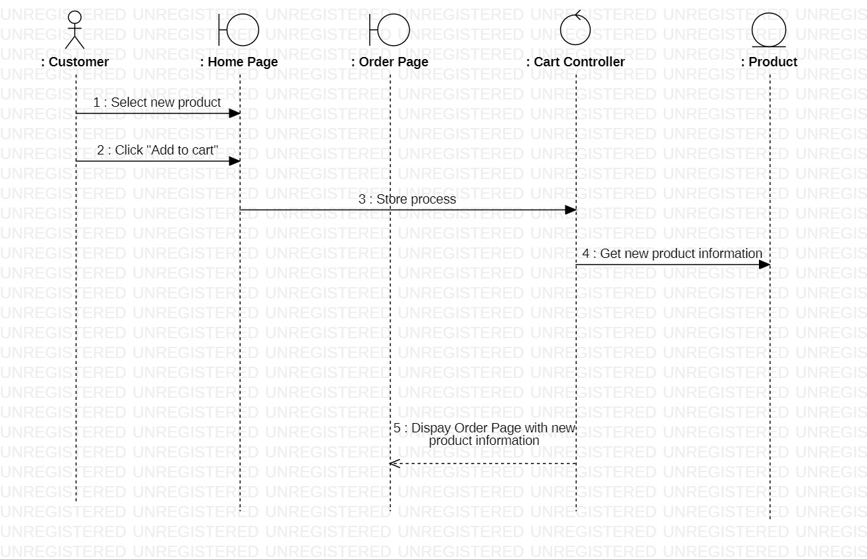

***3.3.8.1.2. Delete from cart***

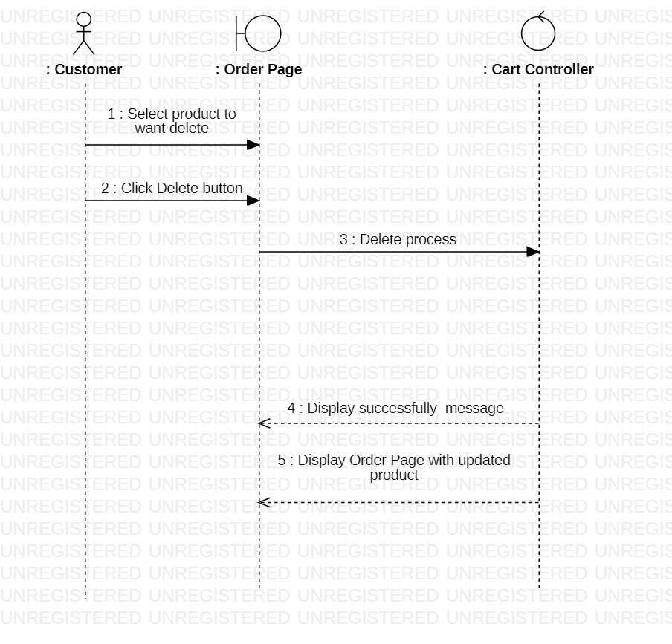

#### **3.3.8.2. Class diagram**

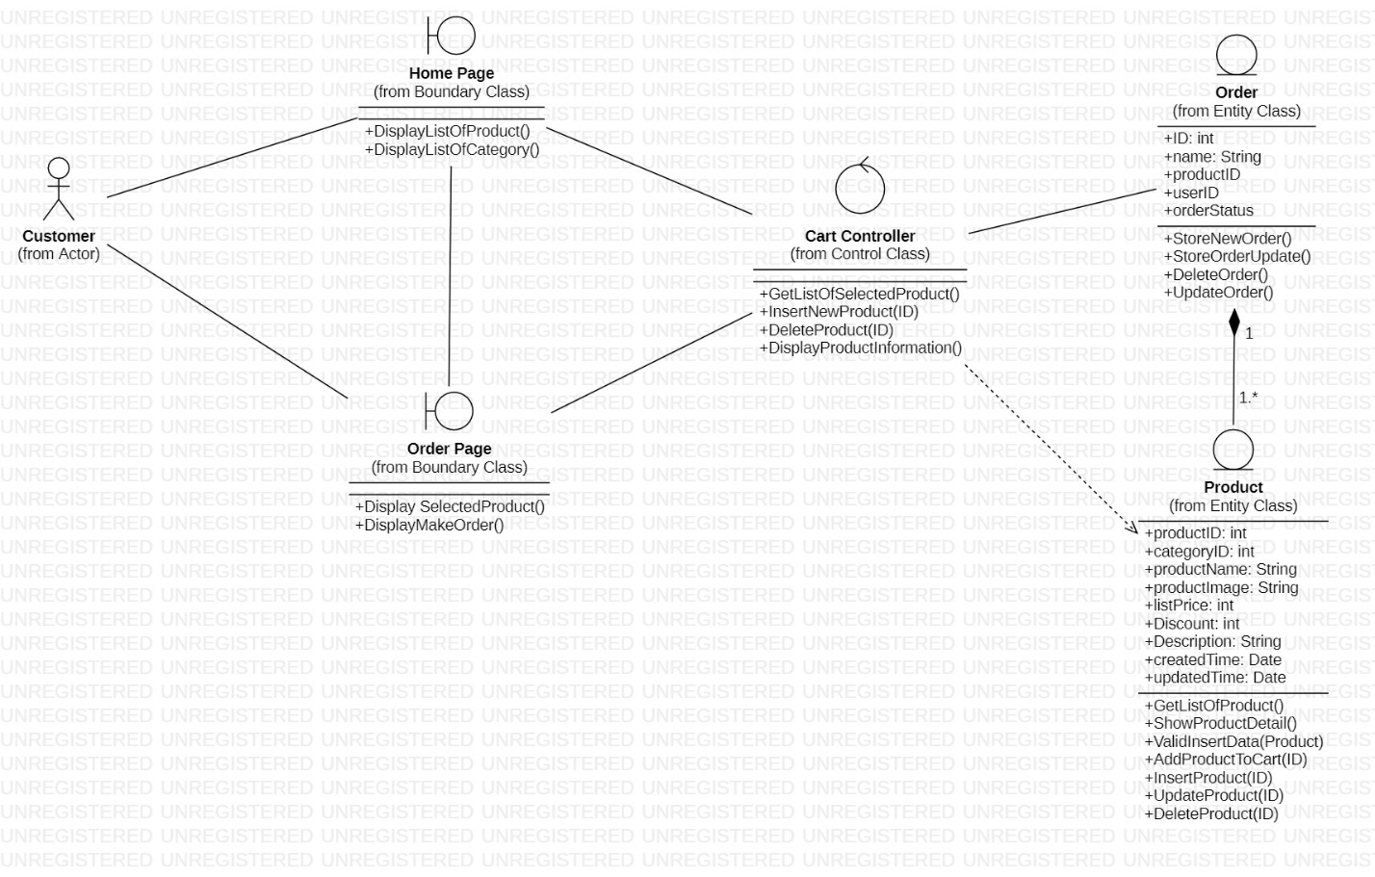

### **3.3.9. Make order**

#### **3.3.9.1. Sequence diagram**

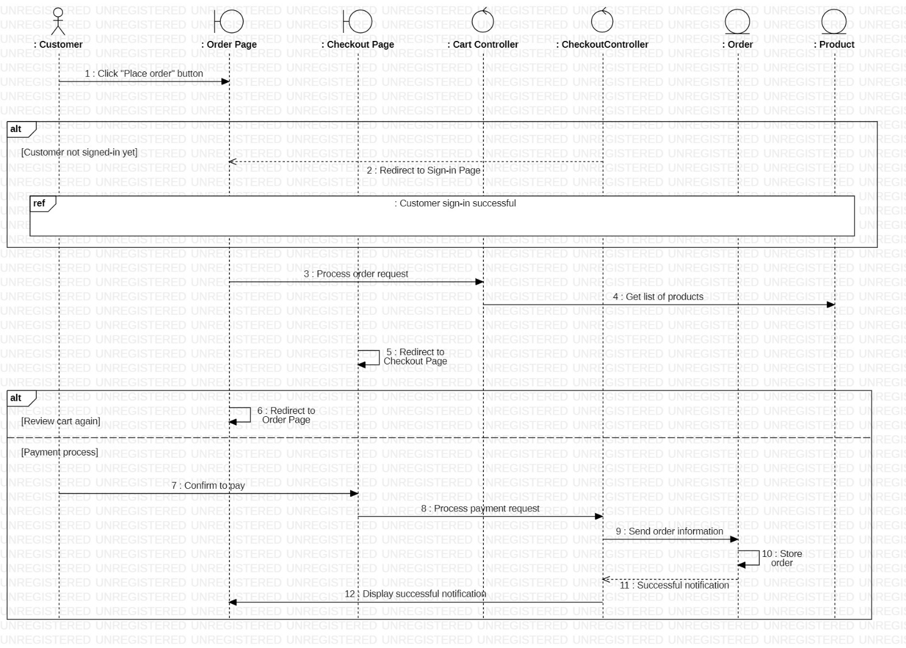

#### **3.3.9.2. Class diagram**

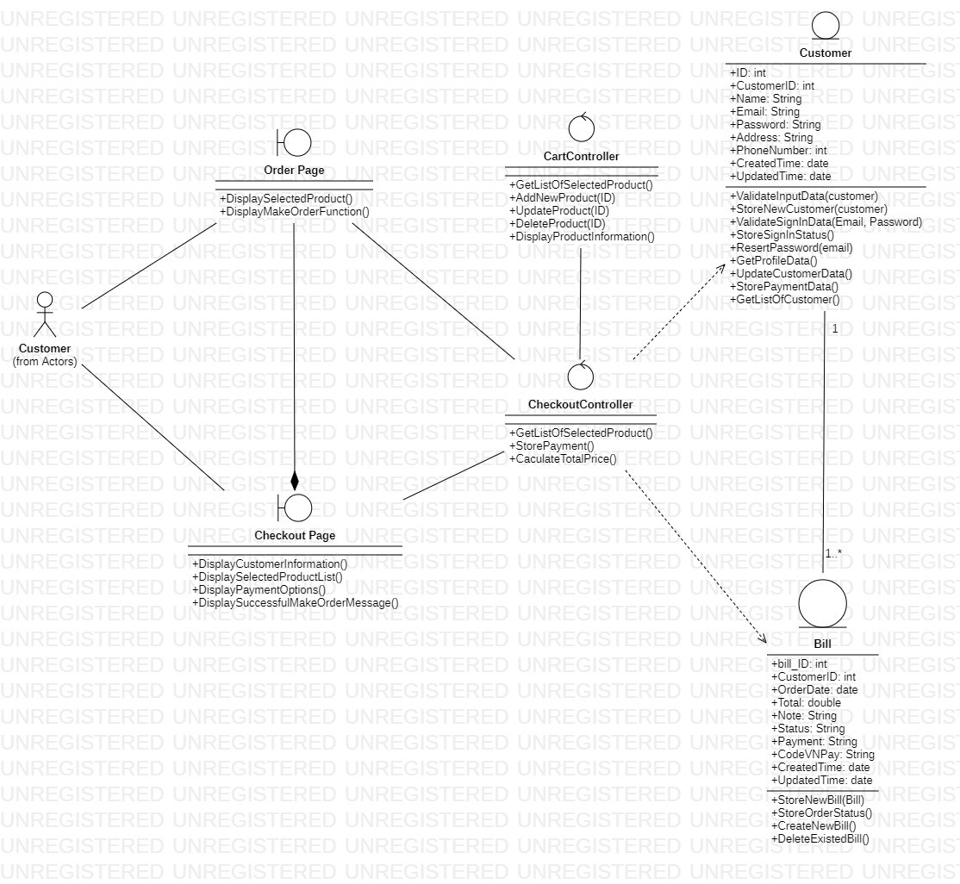

### **3.3.10. View order status**

#### **3.3.10.1. Sequence diagram**

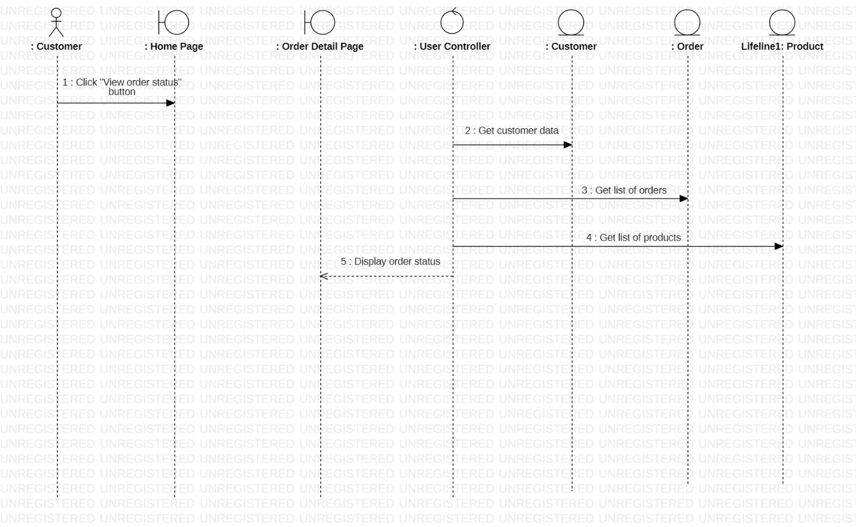

#### **3.3.10.2. Class diagram**

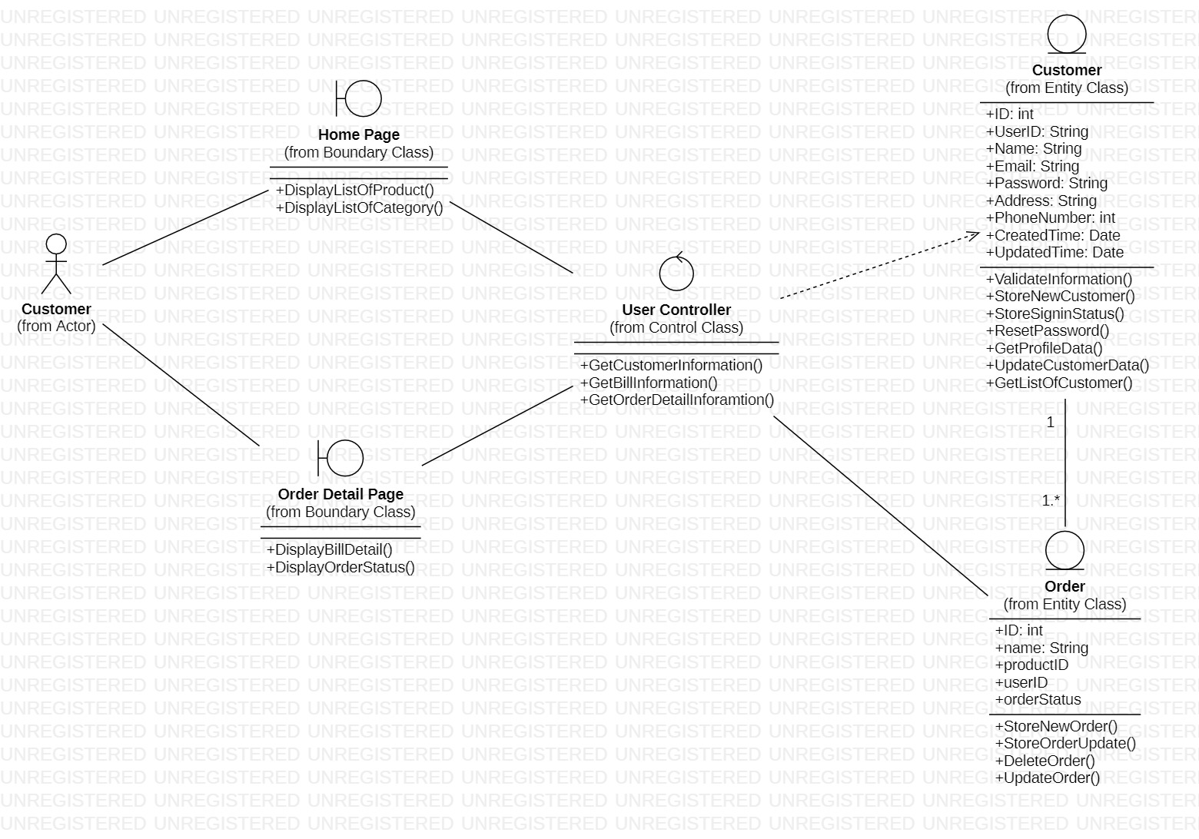

### **3.3.11. Sign in (for Administrator)**

#### **3.3.11.1. Sequence diagram**

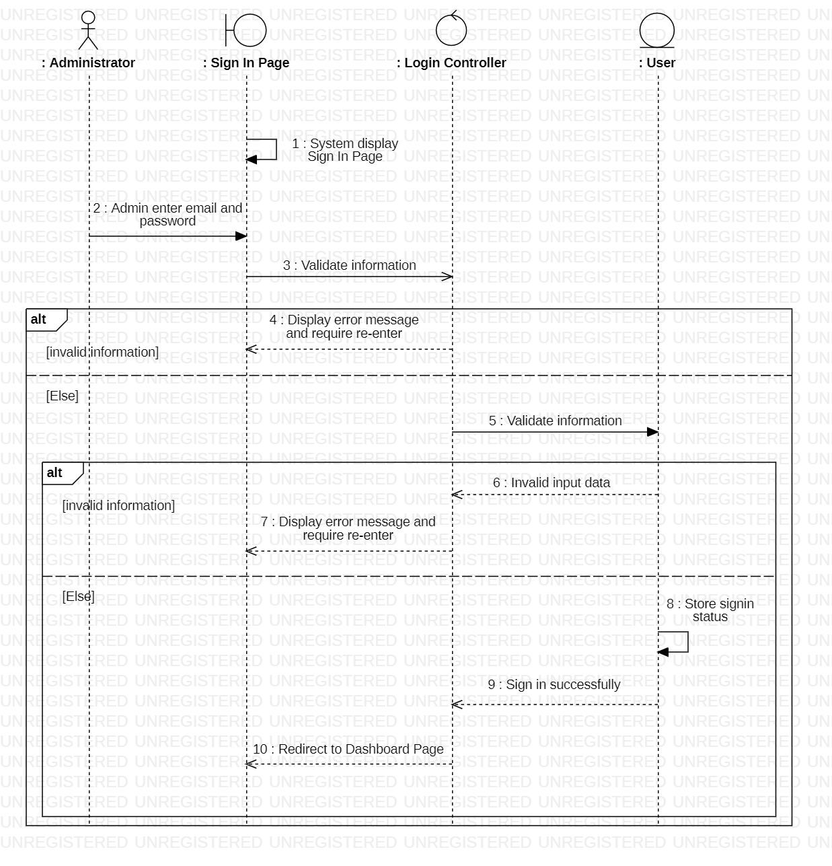

#### **3.3.11.2. Class diagram**



### **3.3.12. Manage product**

#### **3.3.12.1. Sequence diagram**

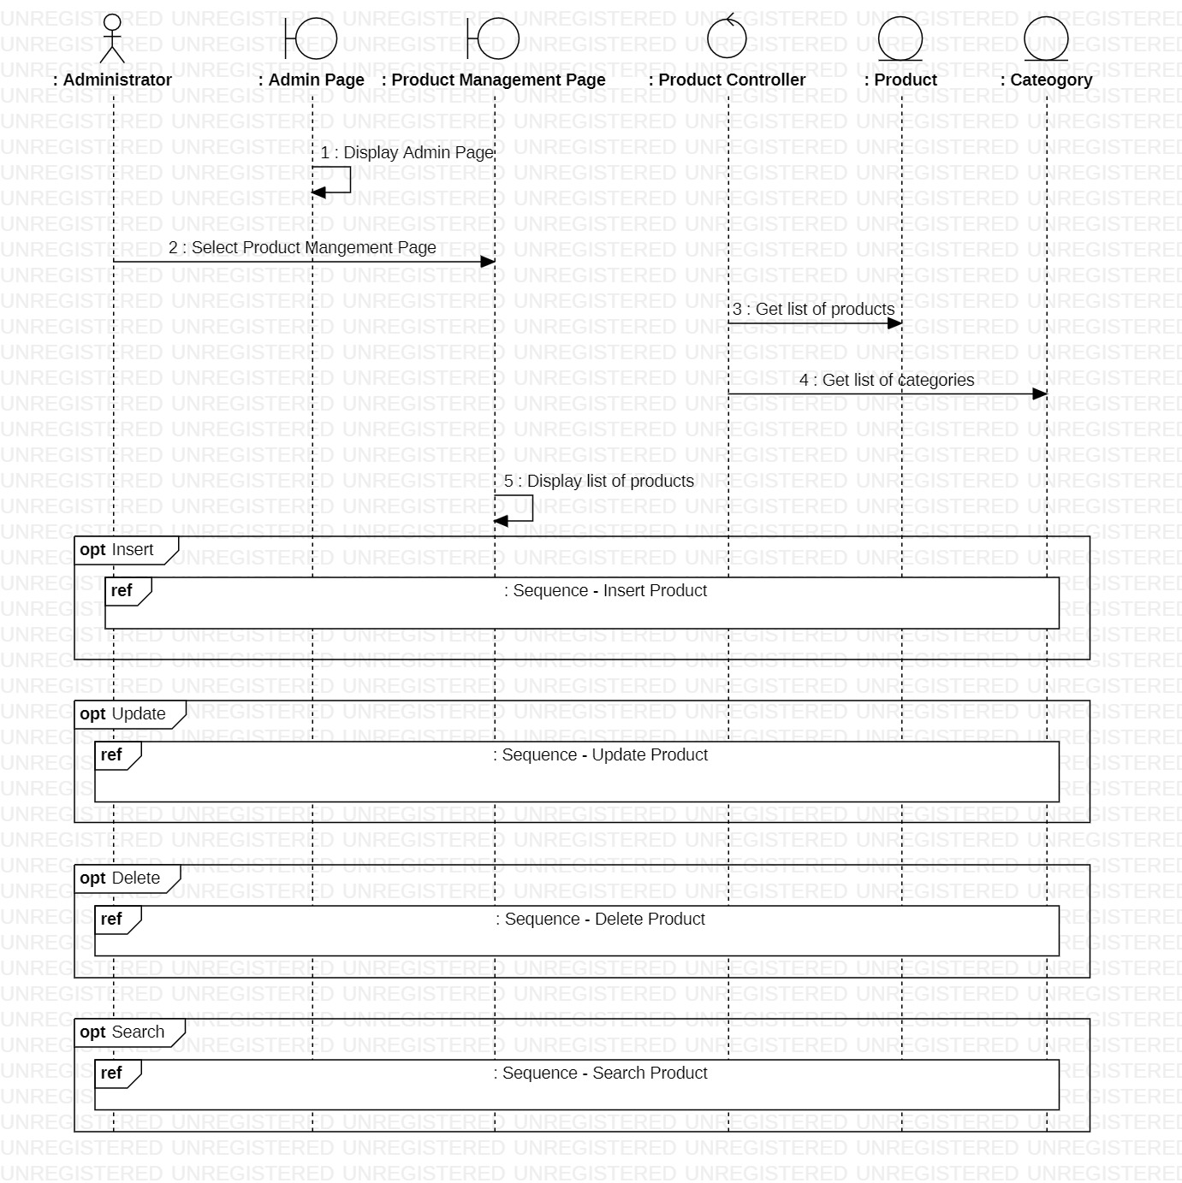

***3.3.12.1.1. Insert product***

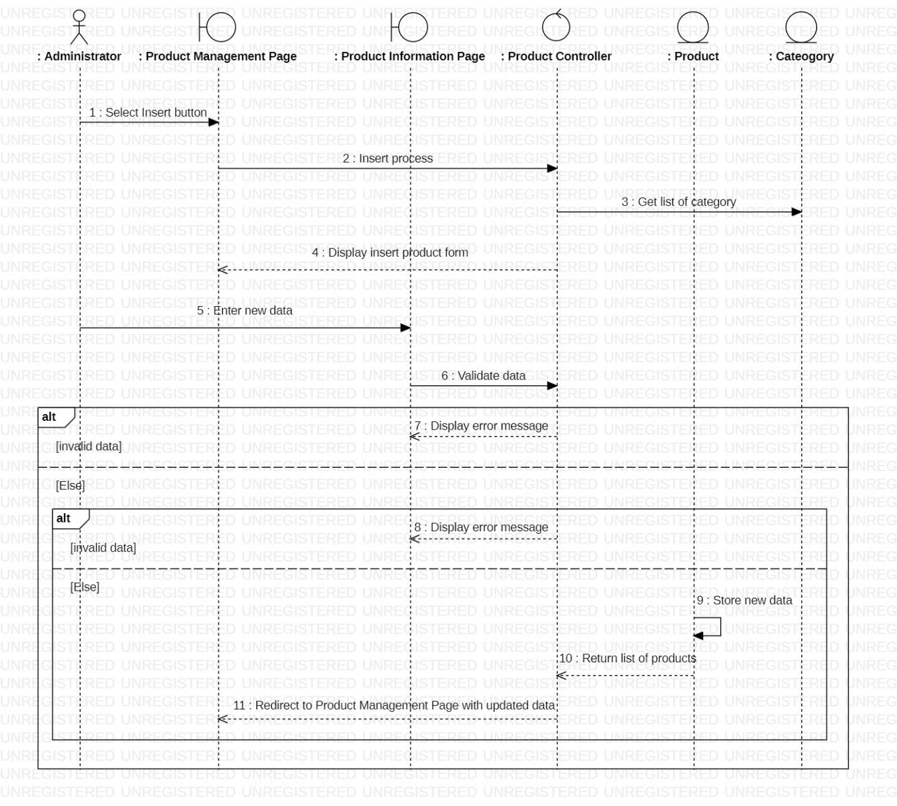

***3.3.12.1.2. Update product***

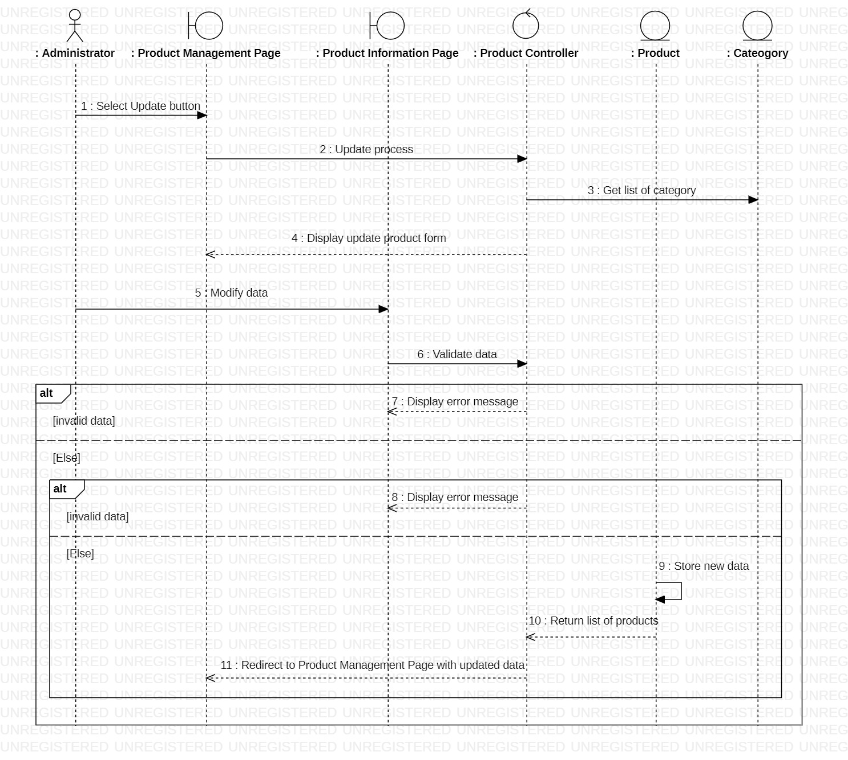

***3.3.12.1.3. Delete product***



***3.3.12.1.4. Search***

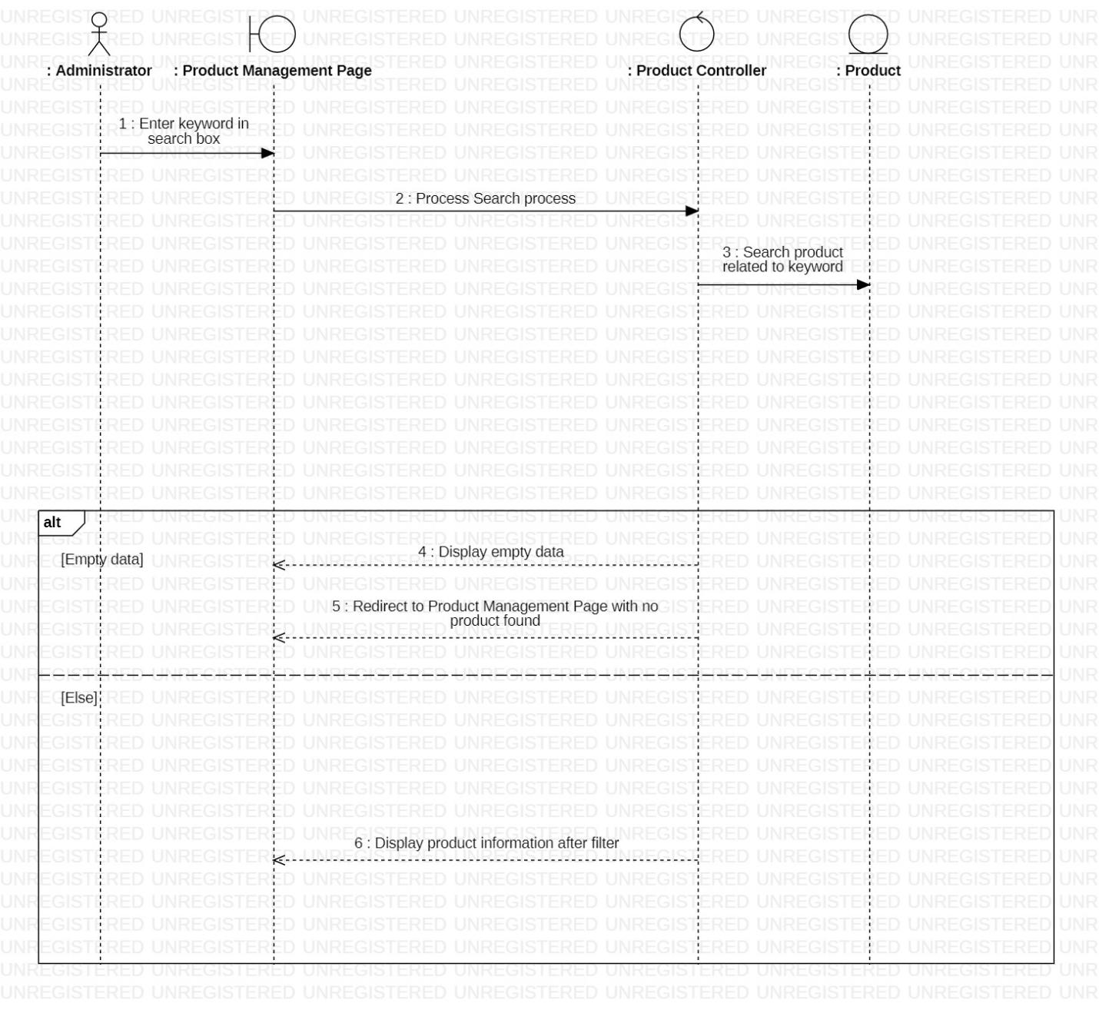

#### **3.3.12.2. Class diagram**

***3.3.12.2.1. Insert, Update, Delete, Search Product***

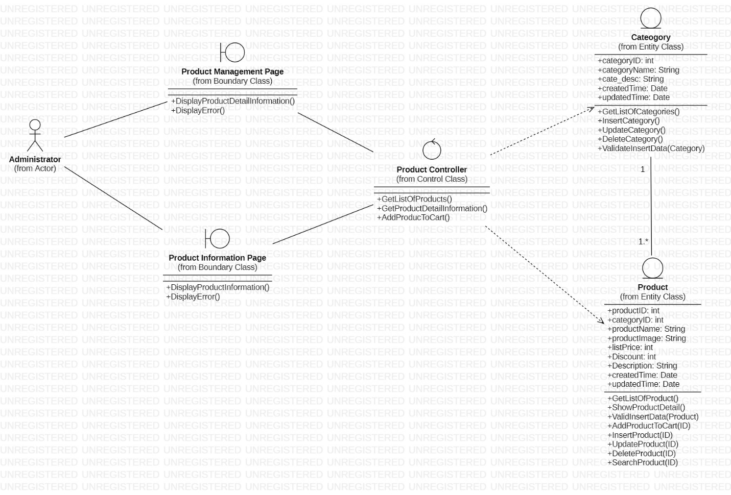

### **3.3.13. Manage order (for Administrator)**

#### **3.3.13.1. Sequence diagram**

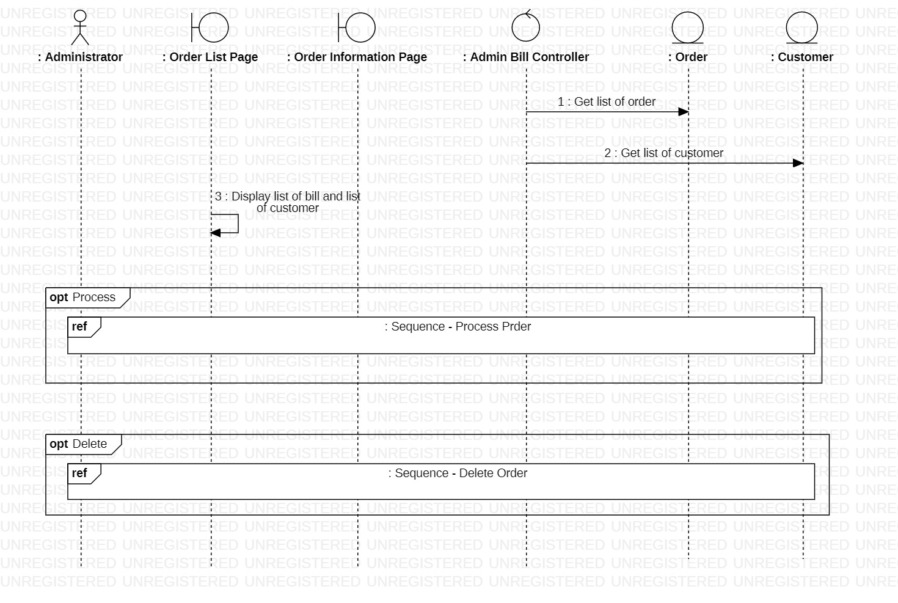

***3.3.13.1.1. Process order***

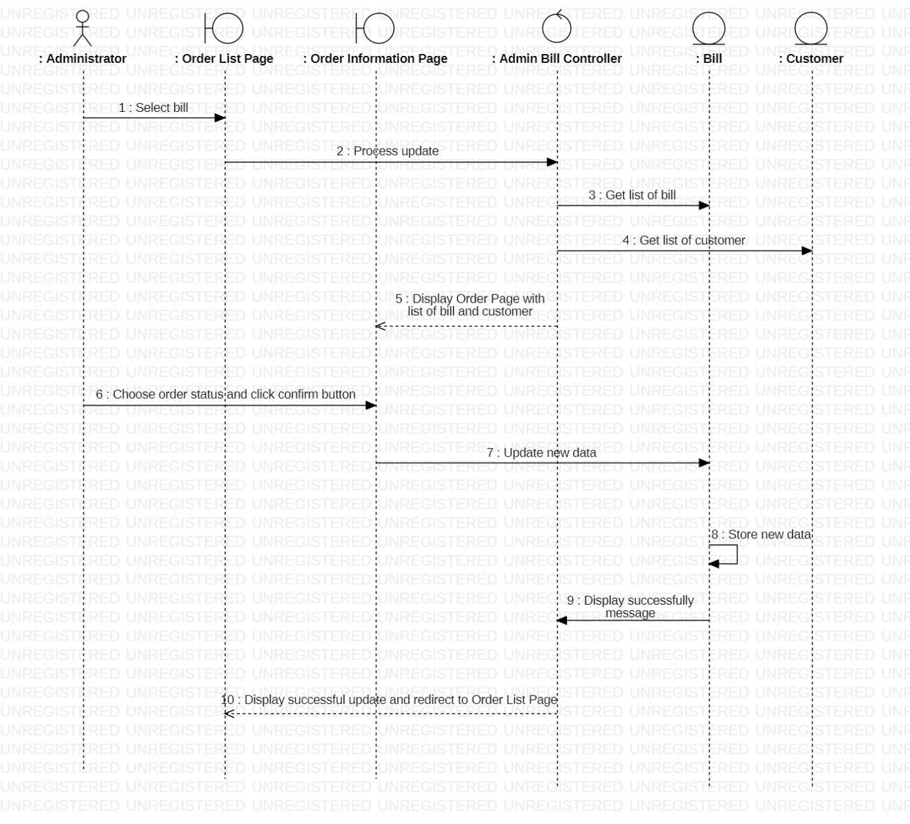

***3.3.13.1.2. Delete order***

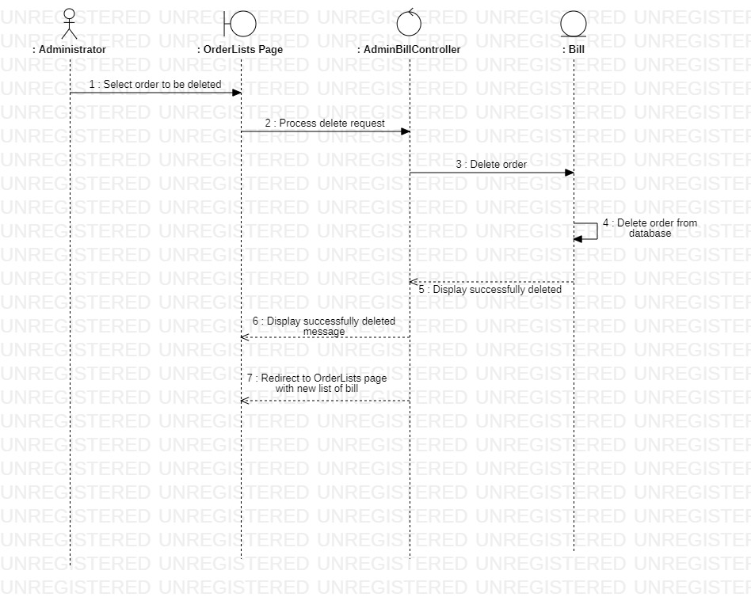

#### **3.3.13.2. Class diagram**

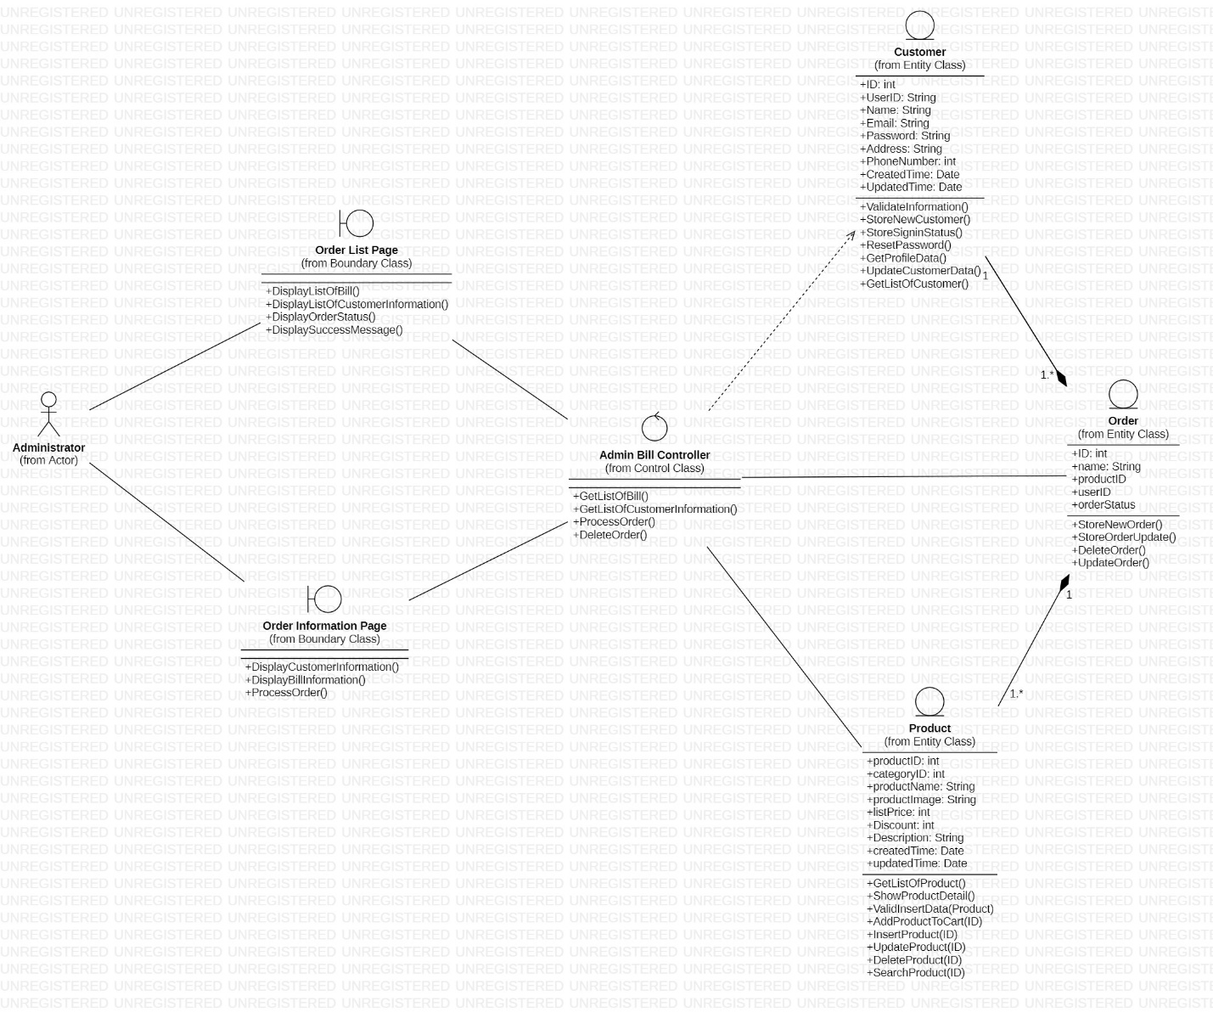

### **3.3.14. Order Statistics**

#### **3.3.14.1. Sequence diagram**

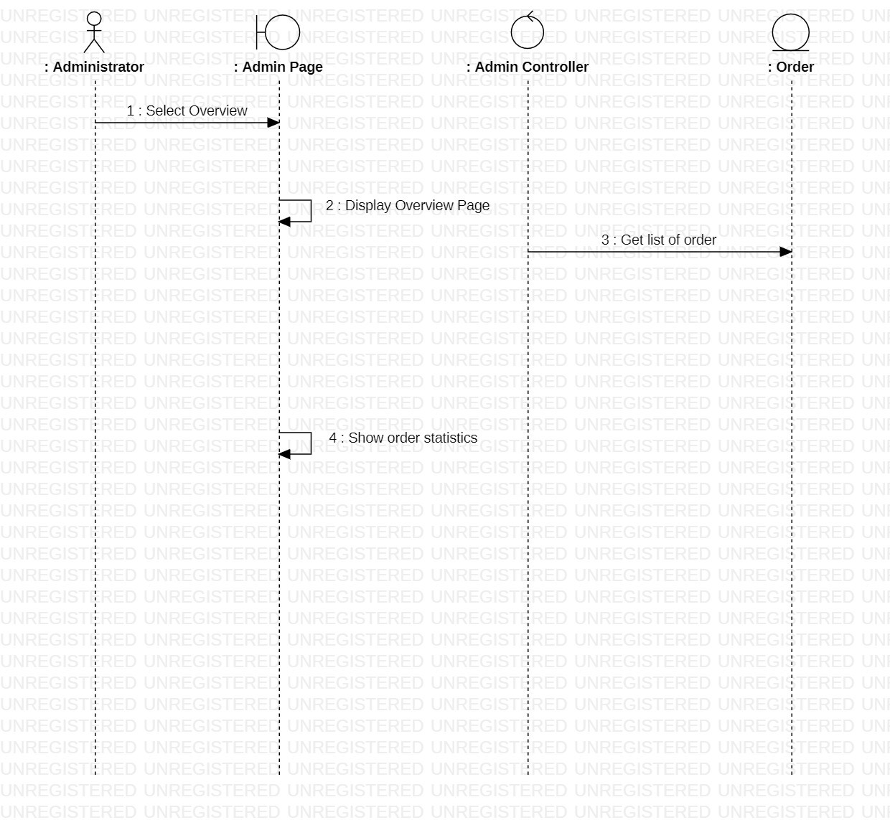

#### **3.3.14.2. Class diagram**

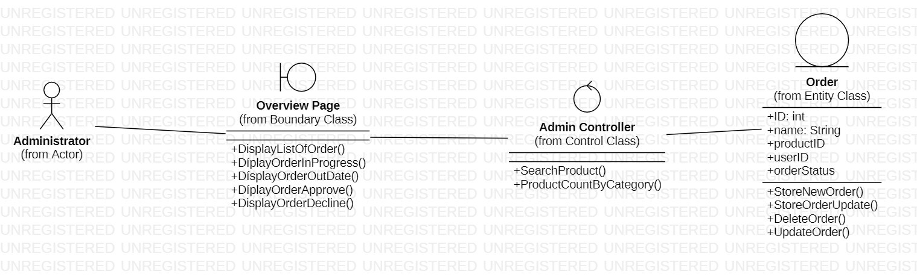

### **3.3.15. Revenue statistic**

#### **3.3.15.1. Sequence diagram**

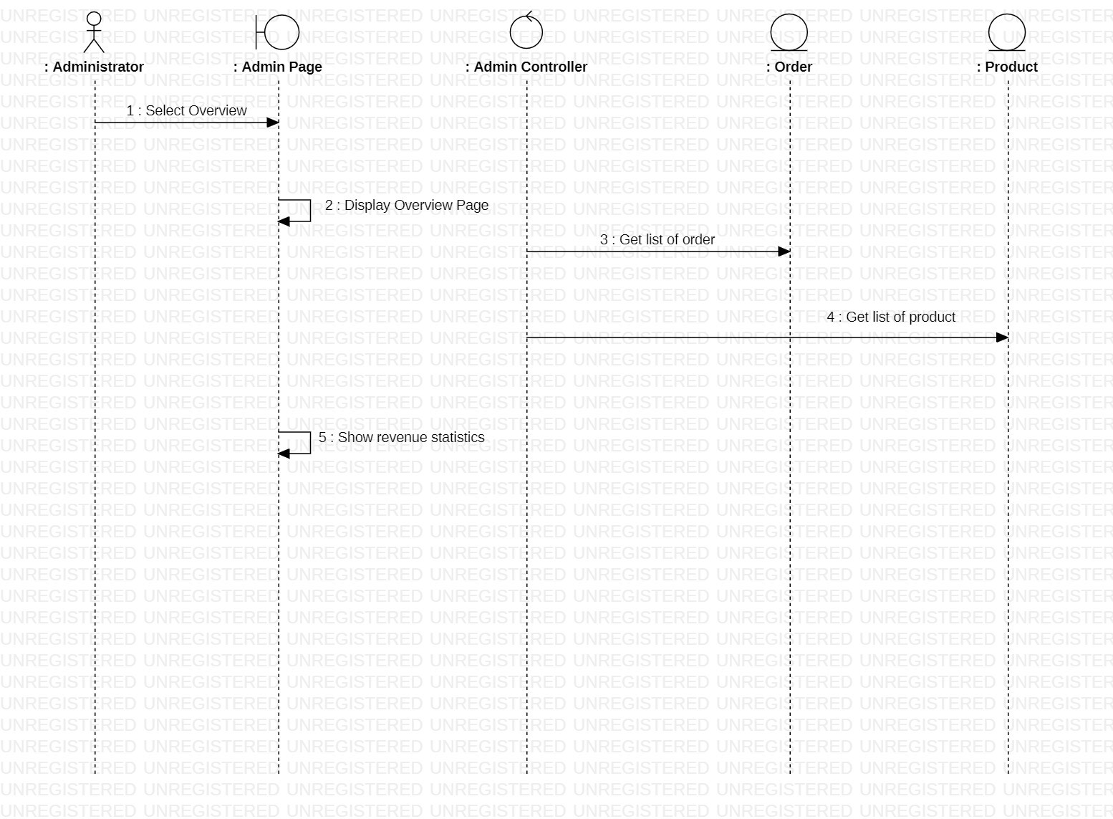

#### **3.3.15.2. Class diagram**

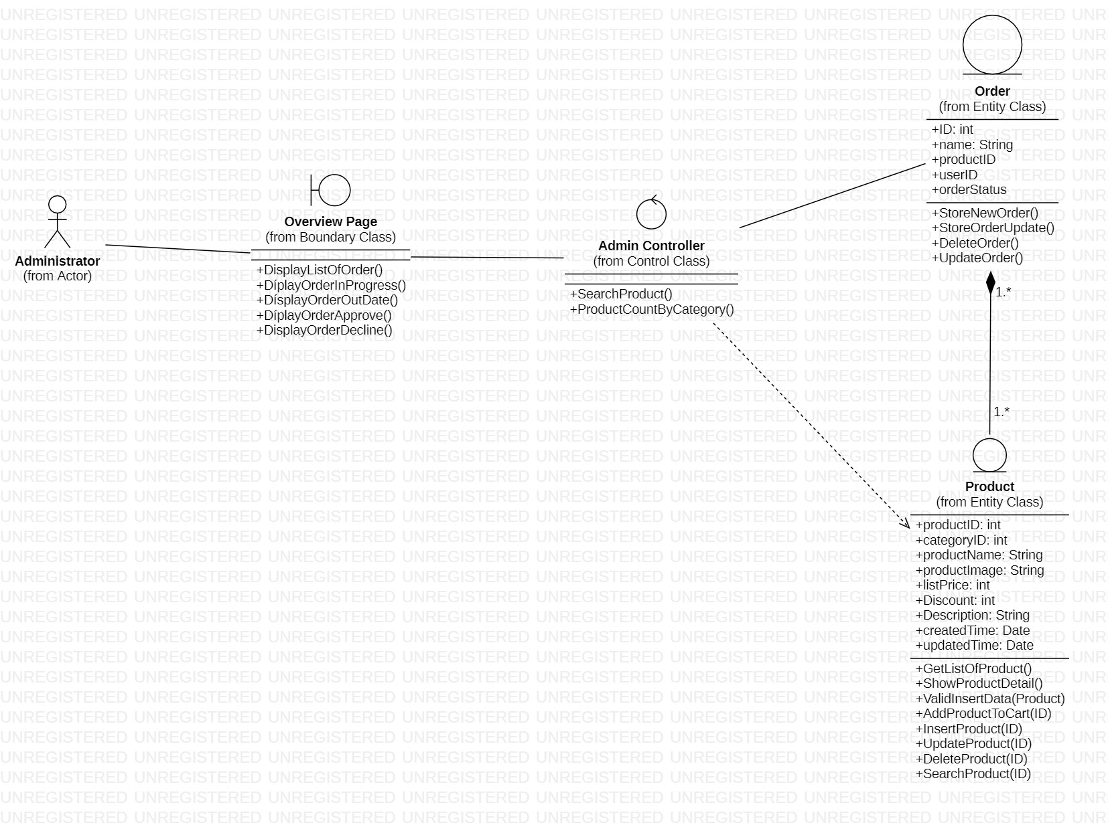

## **3.4. Class diagram and entity class diagram**

### **3.4.1 Customer overview class diagram**

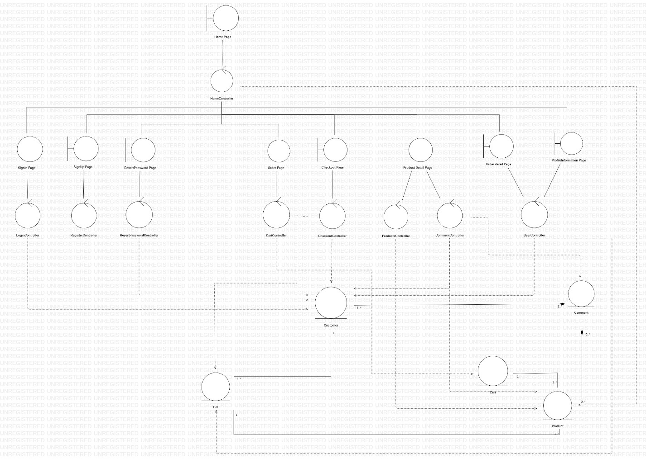

### **3.4.2. Administrator overview class diagram**

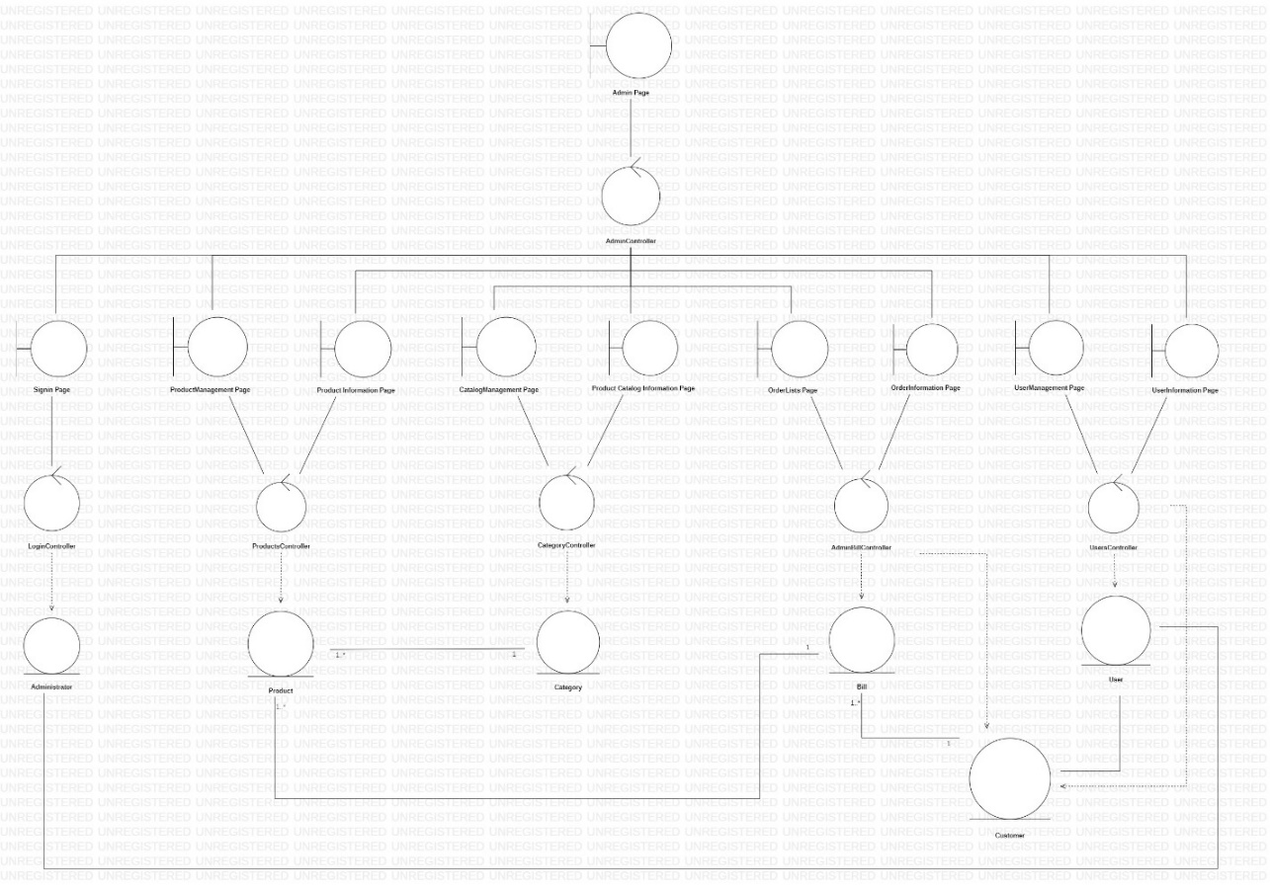

### **3.4.3 Entity class diagram**

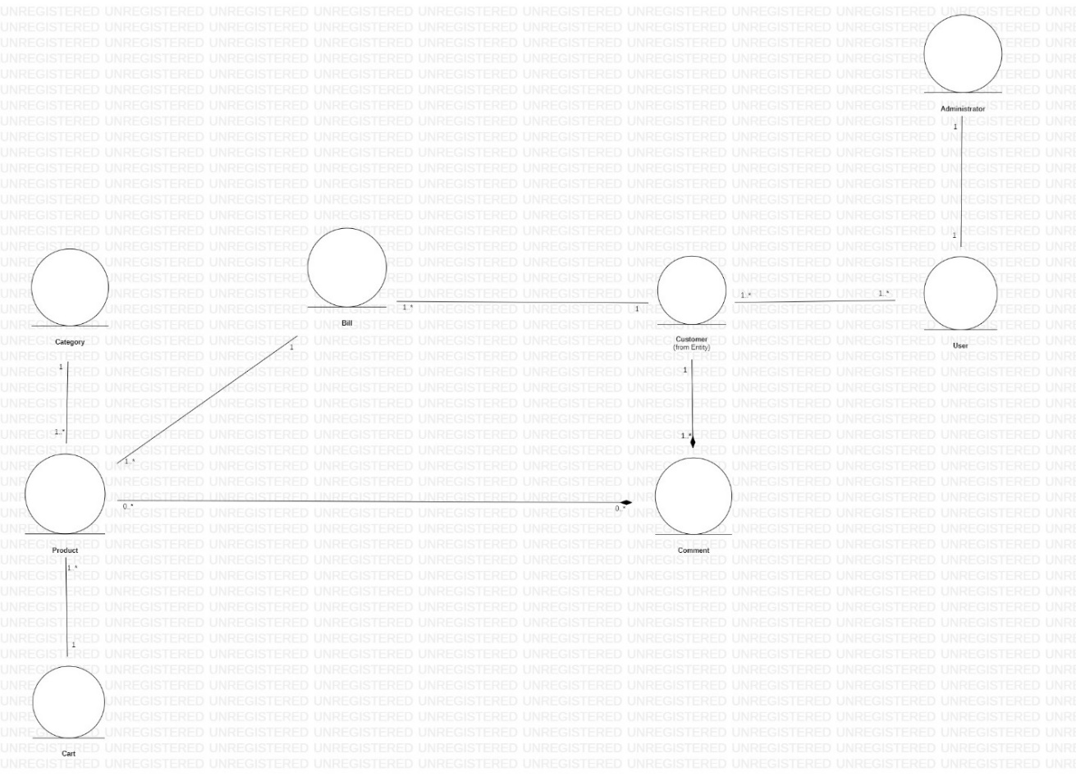

## **3.5. State diagram**

### **3.5.1. Product**

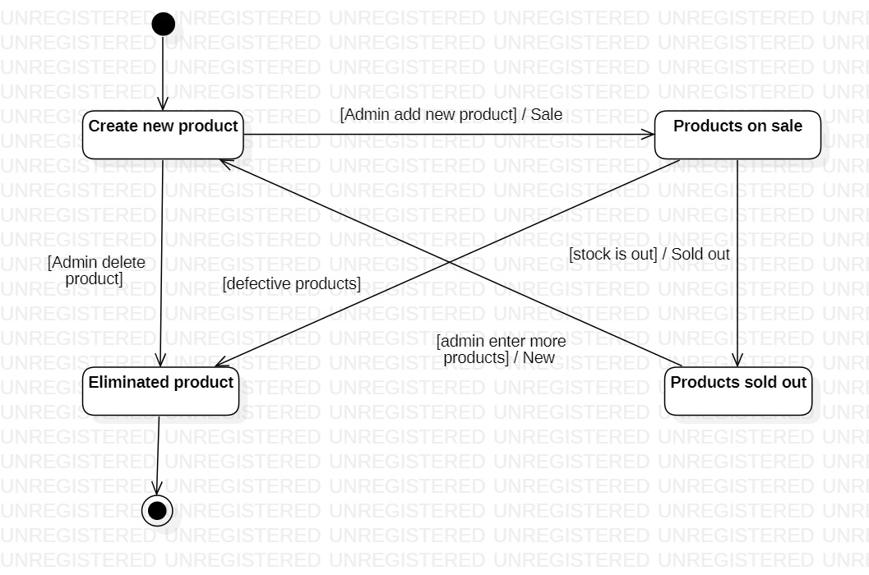

### **3.5.2. Customer account**

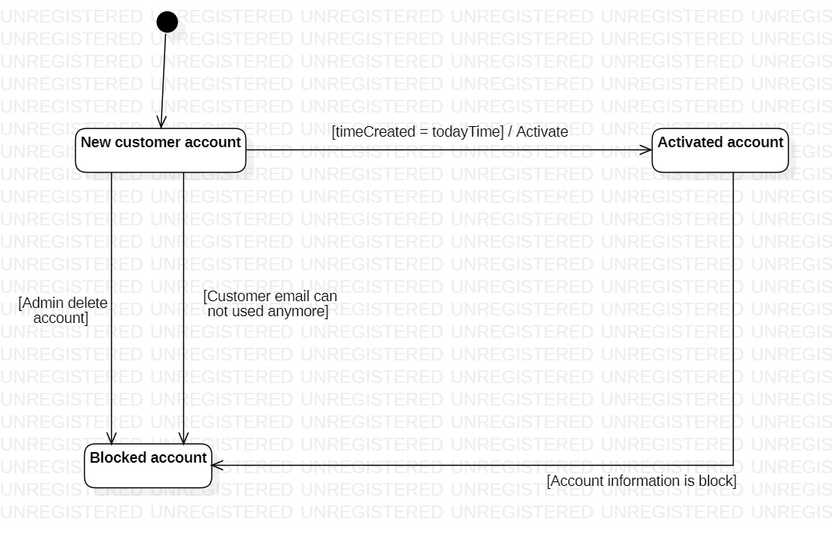

## **3.6. Mapping to Relational Model from Entity class diagram**

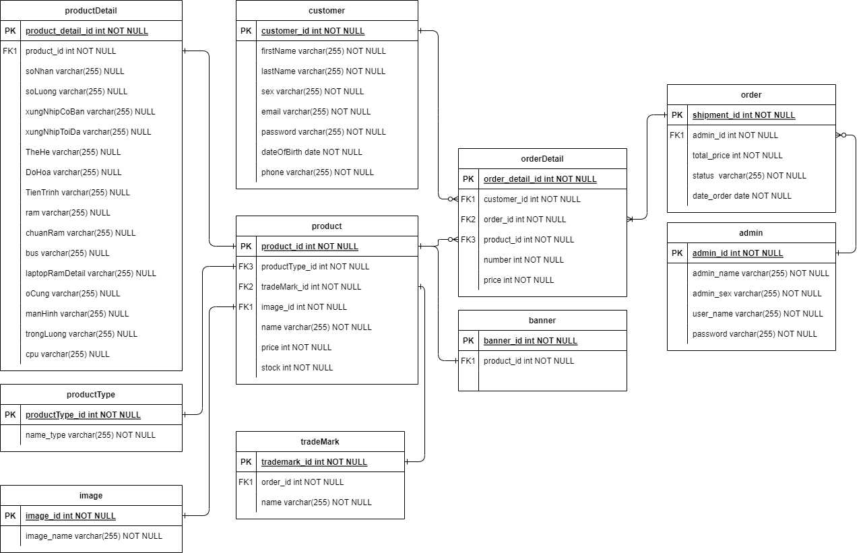

# **CHAPTER 4: IMPLEMENTATION AND TESTING**

## **4.1 Introduction to the implementation environment**

### **4.1.1 Development environment**

* Operating system: Windows 11
* Database: MySQL
* Text Editor: VSCode
* Frontend: Flutter
* Backend: PHP

### **4.1.2 Deployment environment**

* To be installed: XAMPP
* Run XAMPP tools and click start MySQL and Apache model

## **4.2 User Interface**

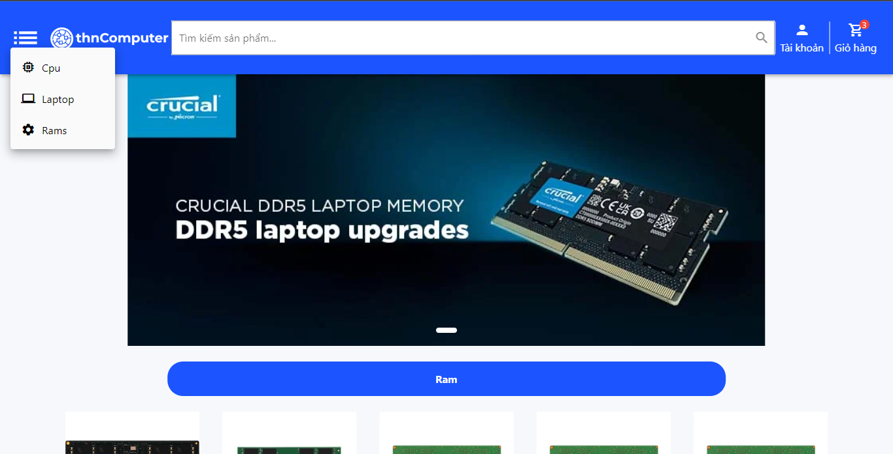

Figure 1.1. Homepage

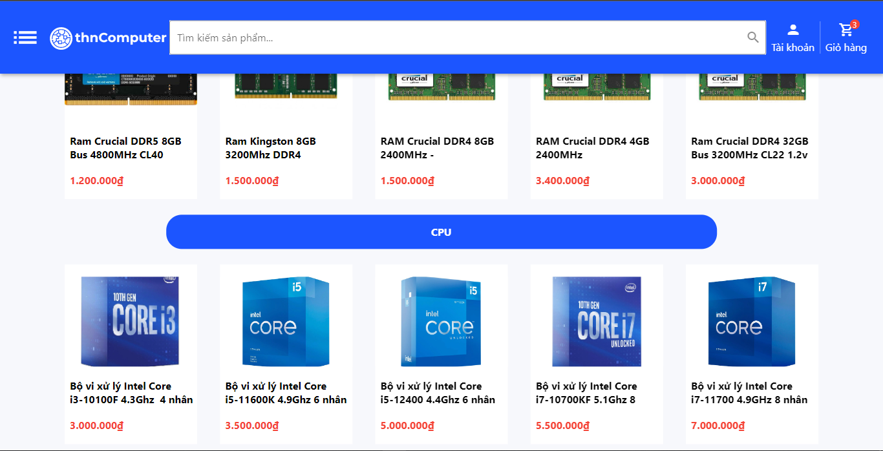

Figure 1.2. Homepage

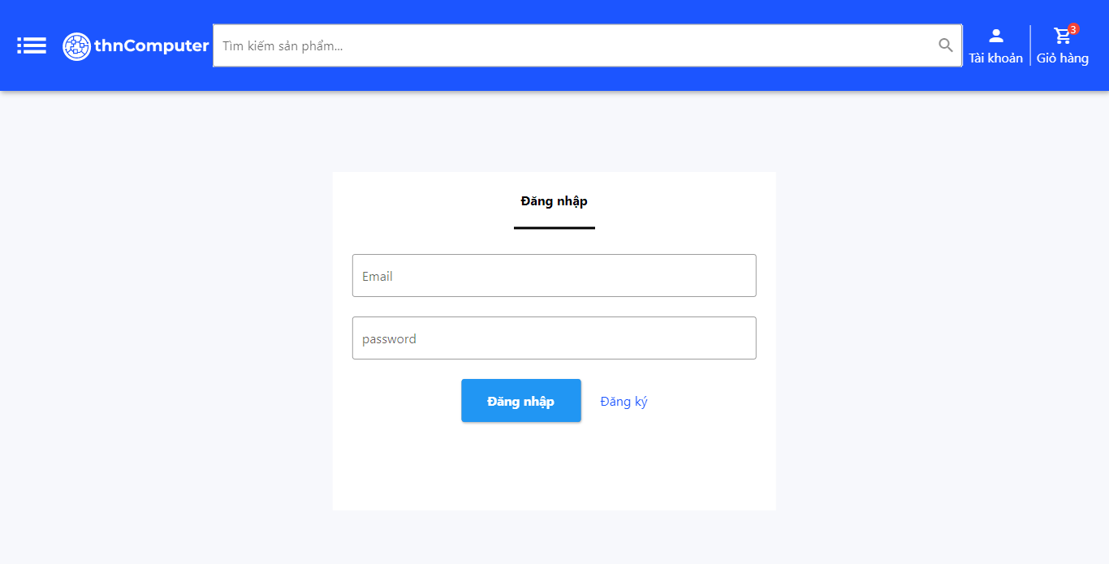

Figure 2. Login page

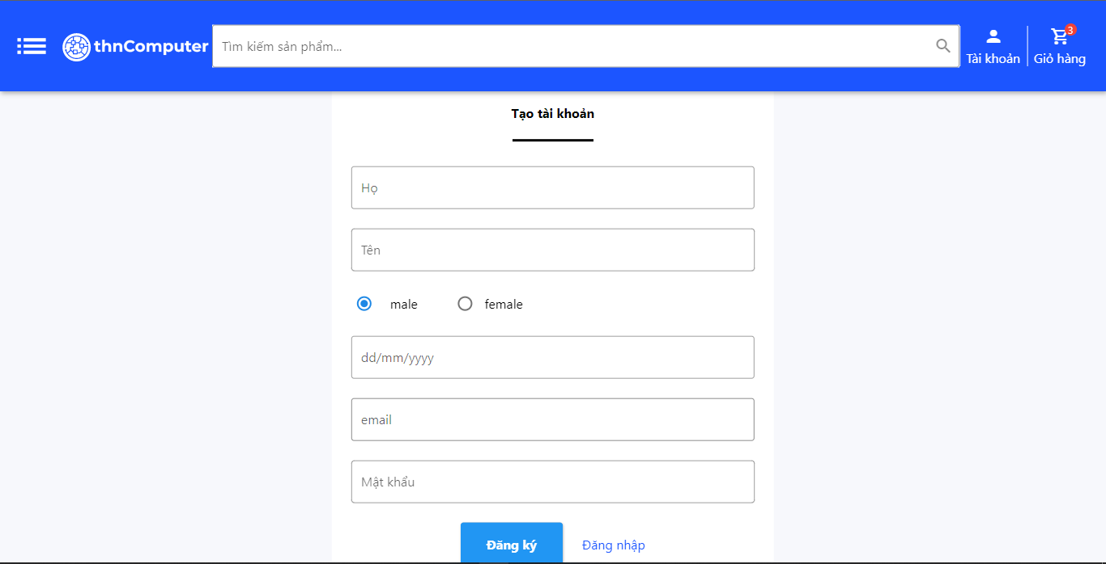

Figure 3. Sign up page

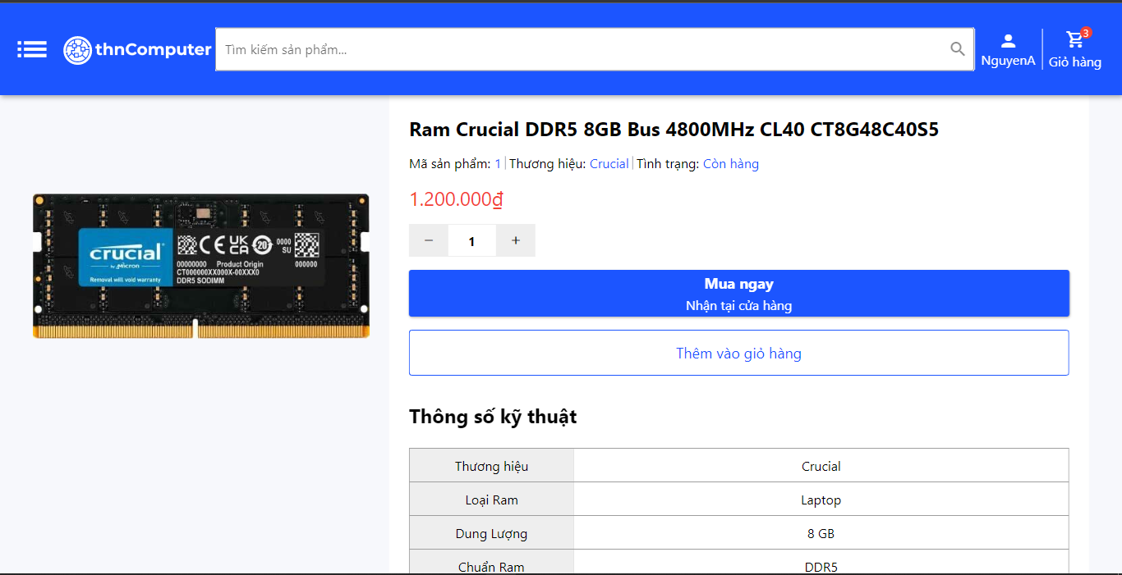

Figure 4.1. Detail Product page

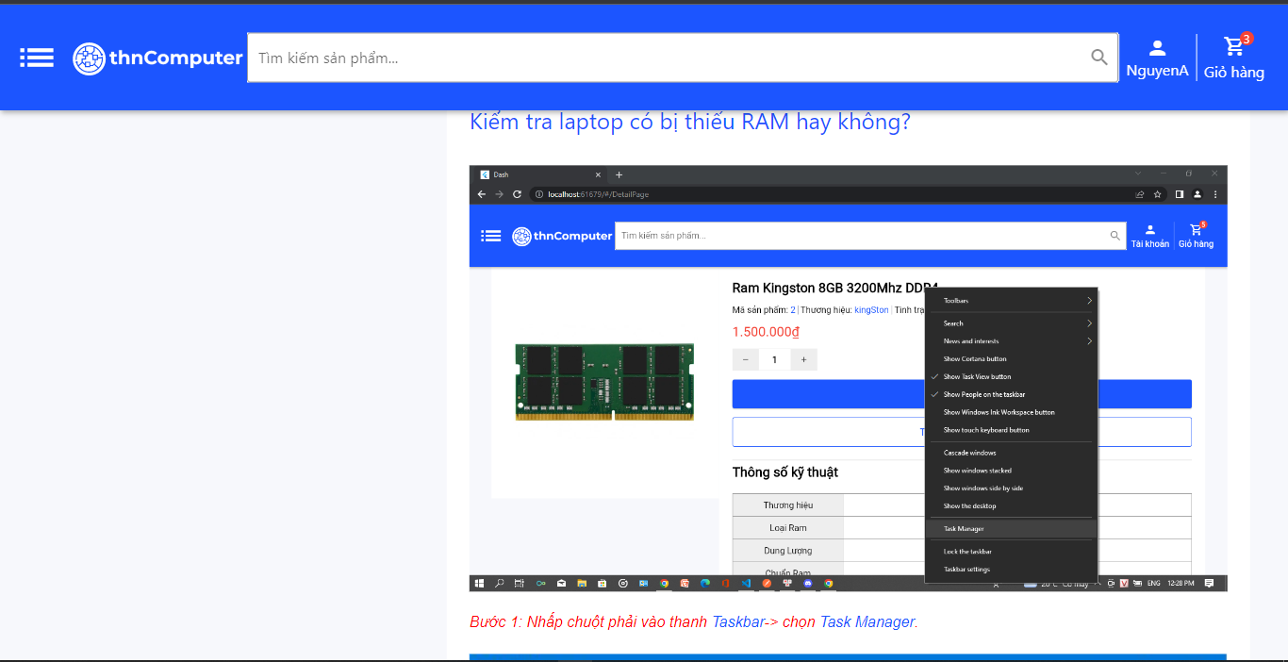

Figure 4.2. Detail Product page

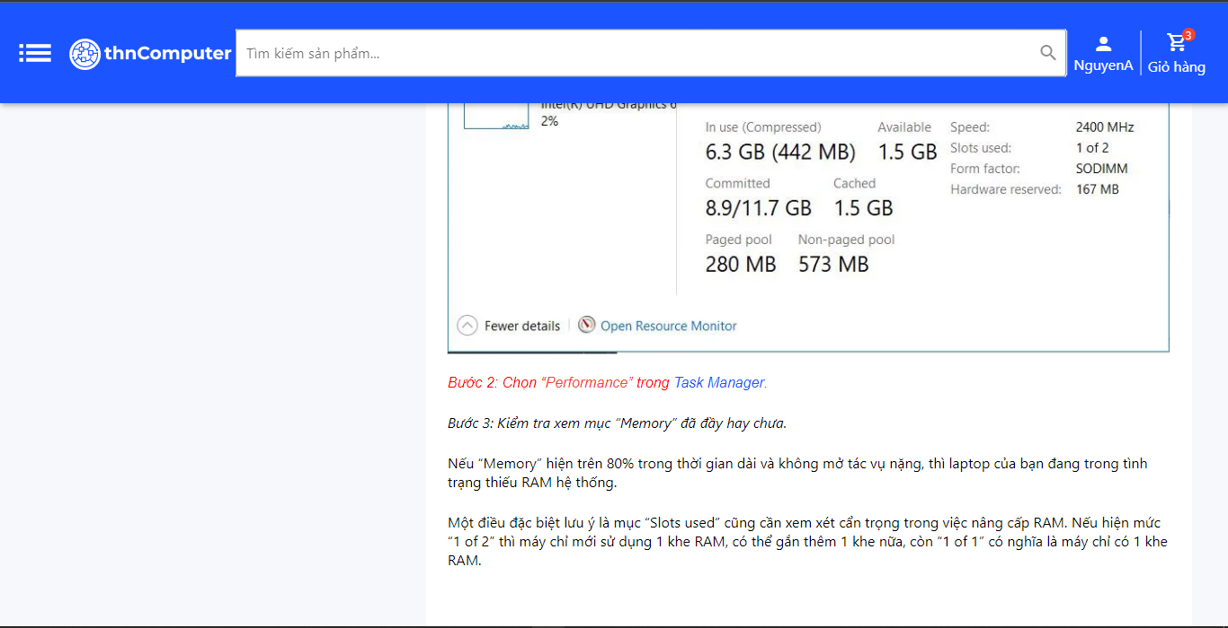

Figure 4.3. Detail Product page

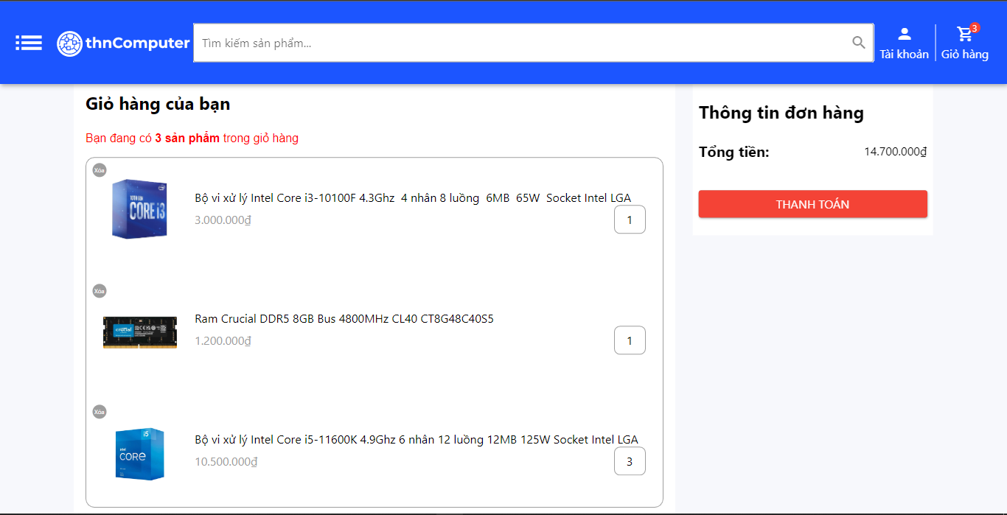

Figure 5. Demo_cart

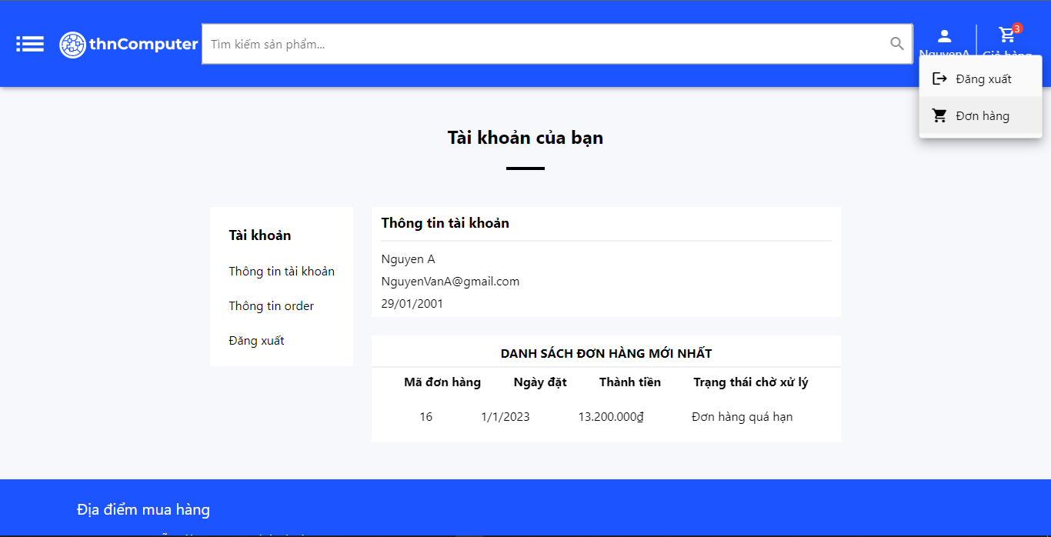

Figure 6. My order page

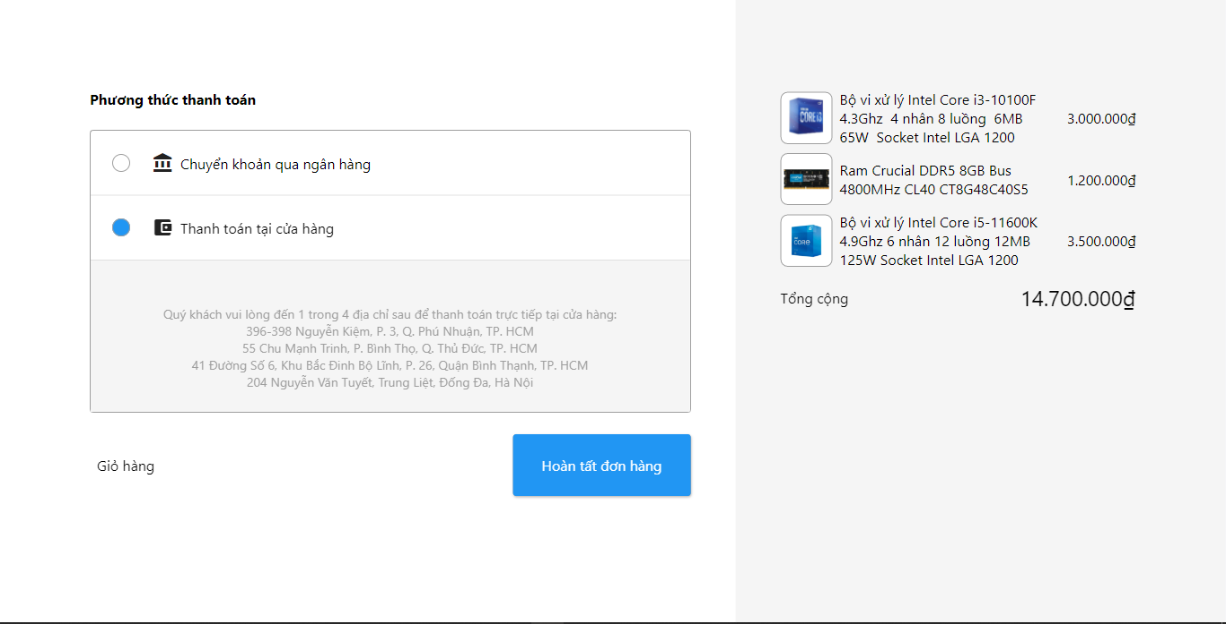

Figure 7. Payment method page

## **4.3. Admin interface**

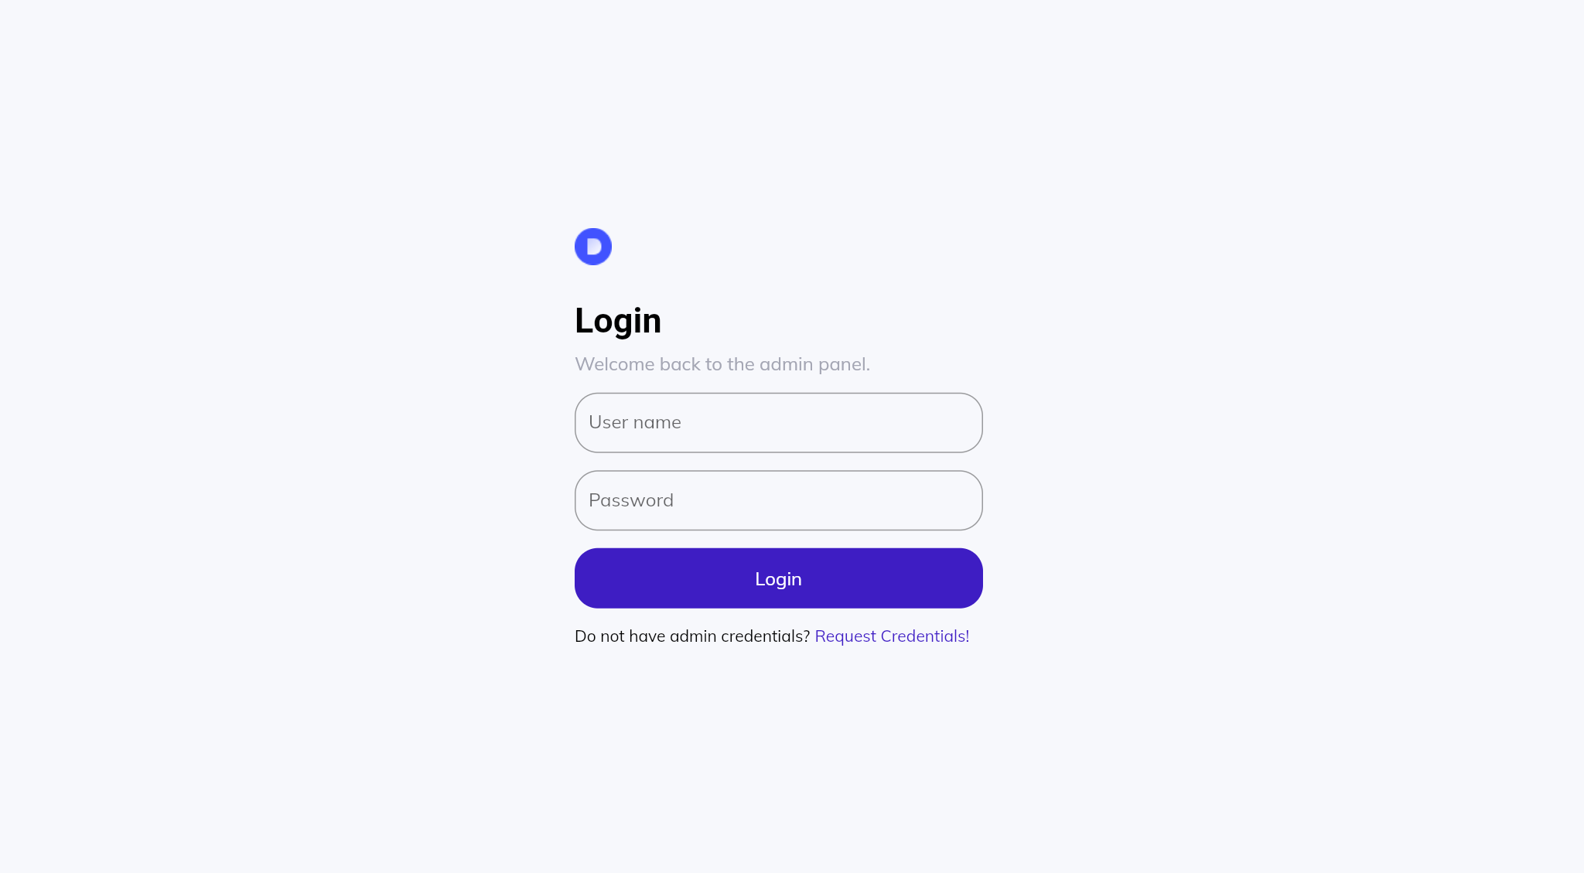

Figure 1. Login Admin page

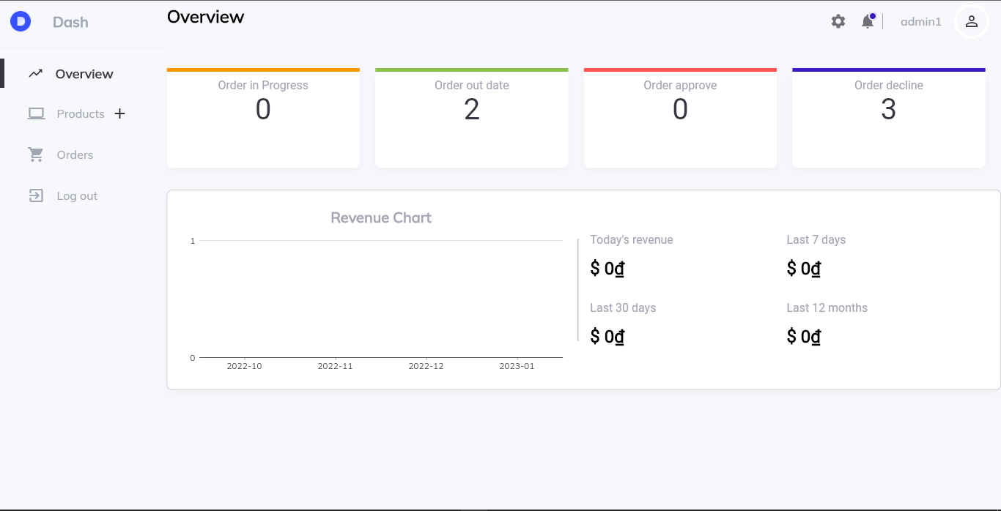

Figure 2. Overview page

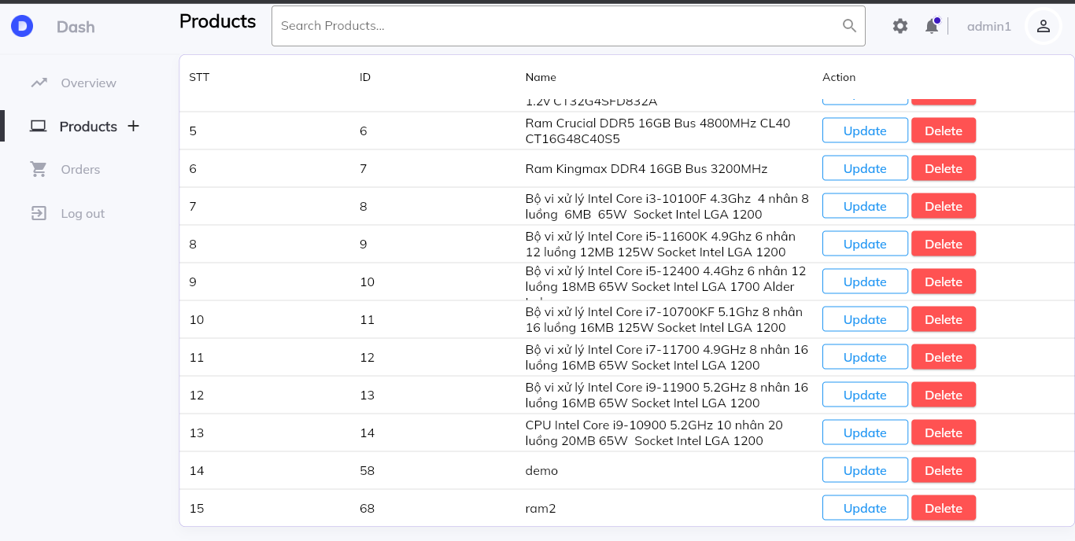

Figure 3. Product Management page

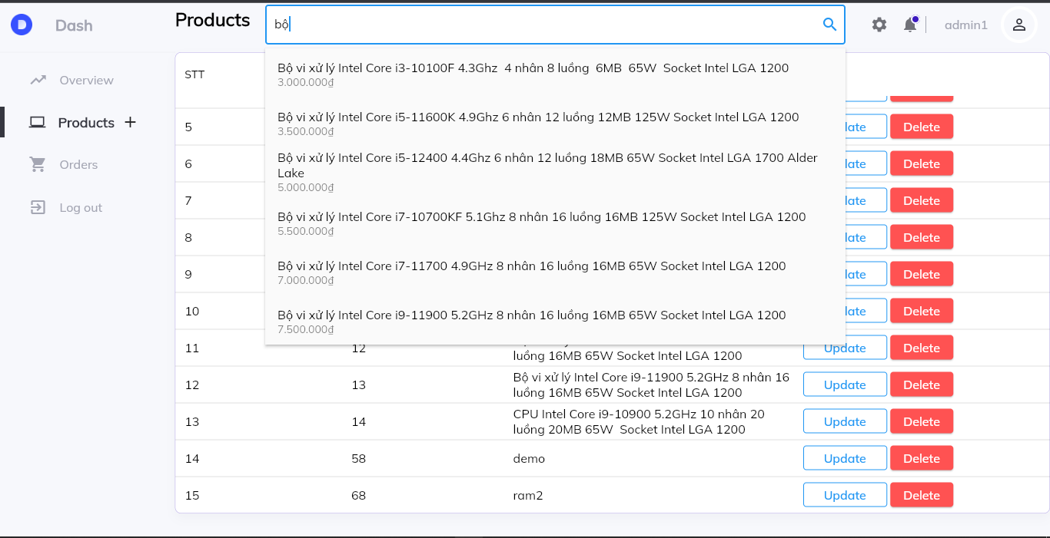

Figure 4. Search page

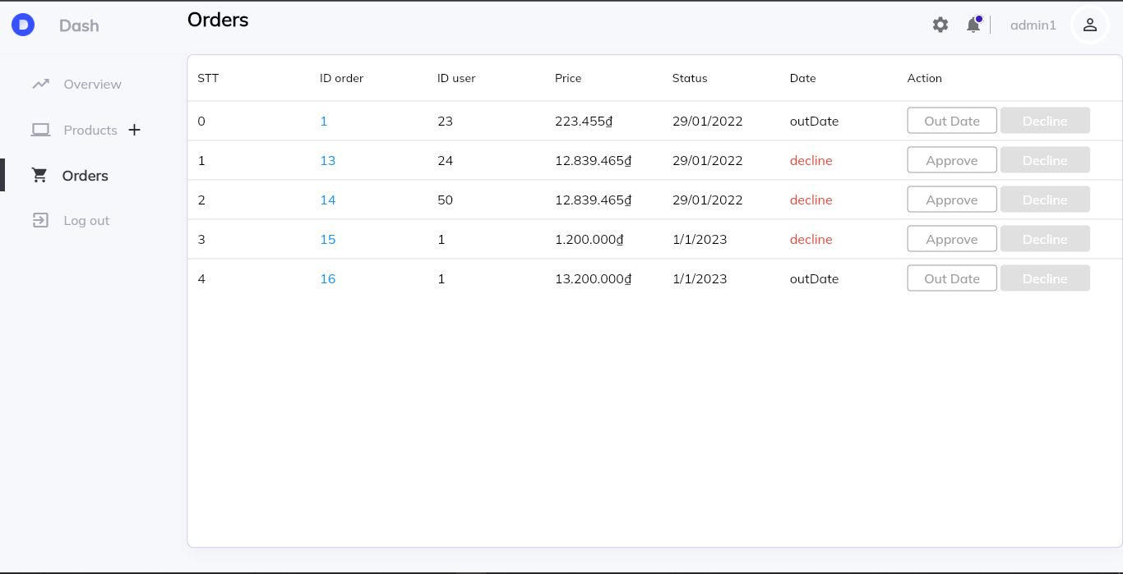

Figure 5. Order Management page

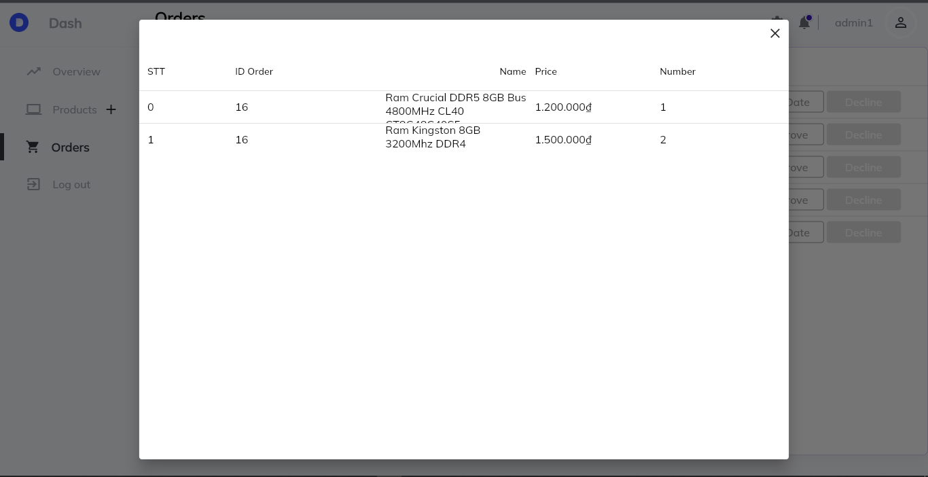

Figure 6. Order Management detail

# **CHAPTER 5: CONCLUSION**

## **5.1 Project achievement**

Nowadays, online shopping has become much more popular. Everyone can easily buy themselves many items at the same time with very simple operations. Especially during the special long break caused by the Covid-19 epidemic. The need to own a computer has also become greater to facilitate remote work. We have built a web platform with a simple interface that is easy to use even for children, with features like messaging with the seller or advising what kind of part to use. Here are a few little add-ons we've created to make shopping problems easier:

* Sign in/Sign up for customer
* Order product
* Chat with consultant
* Product reviews

## **5.2 Limitations**

Due to the limited number of employees in our company and the rush of studying, there are some problems we are facing like:

* Some function work not really well
* The web still does not have the necessary features like checking warehouse or profit analysis

## **5.3 Development goals**

With the aim of creating a simple, user-friendly platform that still comes with many features, in the future our team will develop some more features such as:

* Build PC function: Build your own dream PC
* A Mobile version for mobile user
* Scale website bigger and bigger then move to cloud for security